MD5 Message Digest Algorithm

JERRY LI
Computer Science Department, San Jose State University

Introduction

MD5 algorithm was developed by Professor Ronald L. Rivest in 1991. According to RFC 1321, “MD5 message-digest algorithm takes as input a message of arbitrary length and produces as output a 128-bit "fingerprint" or "message digest" of the input. It is conjectured that it is computationally infeasible to produce two messages having the same message digest, or to produce any message having a given prespecified target message digest. The MD5 algorithm is intended for digital signature applications, where a large file must be "compressed" in a secure manner before being encrypted with a private (secret) key under a public-key cryptosystem such as RSA.”[1] MD5 is considered one of the most efficient algorithms currently available and being used widely today.

MD5 Algorithm Description

MD5 algorithm uses four rounds, each applying one of four non-linear functions to each sixteen 32-bit segments of a 512-bit block source text. The result is a 128-bit digest. Figure 1 is a graph representation that illustrates the structure of the MD5 algorithm.
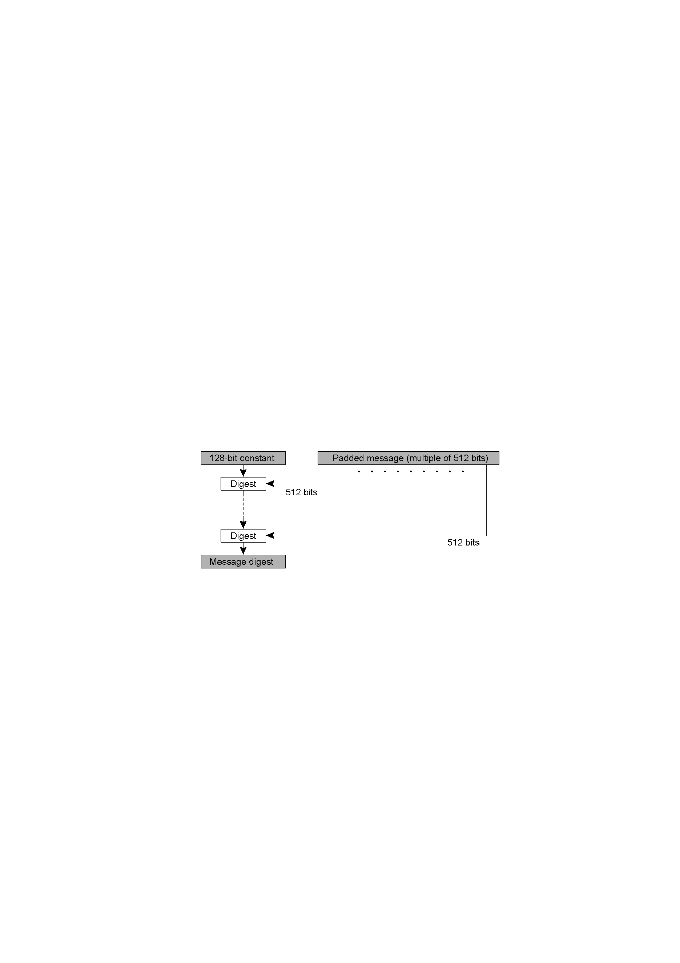

Figure 1. The structure of MD5 algorithm.

MD5 algorithm takes a b-bit message as input, where b is an arbitrary nonnegative integer. The following five steps are performed in C programming language to compute the message digest of the input message.

Step1. Append padding bits

The input message is "padded" (extended) so that its length (in bits) equals to 448 mod 512. Padding is always performed, even if the length of the message is already 448 mod 512. Padding is performed as follows: a single "1" bit is appended to the message, and then "0" bits are appended so that the length in bits of the padded message becomes congruent to 448 mod 512. In all, at least one bit and at most 512 bits are appended.

Step2. Append length

A 64-bit representation of b (the length of the message before the padding bits were added) is appended to the result of step1. If b is greater than 2^64, then only the low-order 64 bits of b are used. (These bits are appended as two 32-bit words and appended low-order word first in accordance with the previous conventions.) The resulting message (after padding with bits and with b) has a length that is an exact multiple of 512 bits. The input message will have a length that is an exact multiple of 16 (32-bit) words. Let M [0 ... N-1] denote the words of the resulting message, where N is a multiple of 16.

Step3. Initialize MD buffer

A four-word buffer (A, B, C, D) is used to compute the message digest. Each of A, B, C, D is a 32-bit register. These registers are initialized to the following values in hexadecimal, low-order bytes first):

word A: 01 23 45 67
word B: 89 ab cd ef
word C: fe dc ba 98
word D: 76 54 32 10

Step4. Process message in 16-word blocks

Four auxiliary functions will be defined such that each function takes an input of three 32-bit words and produces a 32-bit word output.

F (X, Y, Z) = XY or not (X) Z
G (X, Y, Z) = XZ or Y not (Z)
H (X, Y, Z) = X xor Y xor Z
I (X, Y, Z) = Y xor (X or not (Z))

In each bit position, F acts as a condition such that if X then Y else Z. The function F could have been defined using “addition” instead of “or” since XY and not (X) Z will never have 1's in the same bit position.

The functions G, H, and I are similar to the function F, which performs in "bit-wise parallel" to produce its output from the bits of X, Y, and Z so that if the corresponding bits of X, Y, and Z are independent and unbiased. Therefore, each bit of G (X, Y, Z), H (X, Y, Z), and I (X, Y, Z) will be independent and unbiased.

This step uses a 64-element table T [1 ... 64] constructed from the sine function. Let T [i] denote the i-th element of the table, which is equal to the integer part of 4294967296 times abs (sin (i)), where i is in radians. Then, performs the 4 rounds of hashing for each 16-word block:

/* Process each 16-word block. */
For i = 0 to N/16-1 do

/* Copy block i into X. */
For j = 0 to 15 do
Set X[j] to M[i*16+j].
end

/* Save A as AA, B as BB, C as CC, and D as DD. */
AA = A
BB = B
CC = C
DD = D

/* Round 1. */
/*[abcd k s i] denote the operation a = b + ((a + F (b, c, d) + X [k] + T [i]) <<< s). */

/* Do the following 16 operations. */
[ABCD 0 7 1] [DABC 1 12 2] [CDAB 2 17 3] [BCDA 3 22 4]
[ABCD 4 7 5] [DABC 5 12 6] [CDAB 6 17 7] [BCDA 7 22 8]
[ABCD 8 7 9] [DABC 9 12 10] [CDAB 10 17 11] [BCDA 11 22 12]
[ABCD 12 7 13] [DABC 13 12 14] [CDAB 14 17 15] [BCDA 15 22 16]

/* Round 2. */
/*[abcd k s i] denote the operation a = b + ((a + G (b, c, d) + X [k] + T [i]) <<< s). */

/* Do the following 16 operations. */
[ABCD 1 5 17] [DABC 6 9 18] [CDAB 11 14 19] [BCDA 0 20 20]
[ABCD 5 5 21] [DABC 10 9 22] [CDAB 15 14 23] [BCDA 4 20 24]
[ABCD 9 5 25] [DABC 14 9 26] [CDAB 3 14 27] [BCDA 8 20 28]
[ABCD 13 5 29] [DABC 2 9 30] [CDAB 7 14 31] [BCDA 12 20 32]

/* Round 3. */
/*[abcd k s t] denote the operation a = b + ((a + H (b, c, d) + X [k] + T [i]) <<< s). */

/* Do the following 16 operations. */
[ABCD 5 4 33] [DABC 8 11 34] [CDAB 11 16 35] [BCDA 14 23 36]
[ABCD 1 4 37] [DABC 4 11 38] [CDAB 7 16 39] [BCDA 10 23 40]
[ABCD 13 4 41] [DABC 0 11 42] [CDAB 3 16 43] [BCDA 6 23 44]
[ABCD 9 4 45] [DABC 12 11 46] [CDAB 15 16 47] [BCDA 2 23 48]

/* Round 4. */
/*[abcd k s t] denote the operation a = b + ((a + I(b,c,d) + X[k] + T[i]) <<< s). */

/* Do the following 16 operations. */
[ABCD 0 6 49] [DABC 7 10 50] [CDAB 14 15 51] [BCDA 5 21 52]
[ABCD 12 6 53] [DABC 3 10 54] [CDAB 10 15 55] [BCDA 1 21 56]
[ABCD 8 6 57] [DABC 15 10 58] [CDAB 6 15 59] [BCDA 13 21 60]
[ABCD 4 6 61] [DABC 11 10 62] [CDAB 2 15 63] [BCDA 9 21 64]

/* perform the following additions, which increment each of the four registers by the value it
had before this block was started. */

A = A + AA
B = B + BB
C = C + CC
D = D + DD
Step5. Output

The message digest produced is A, B, C, and D, beginning with the low-order byte of A, and end with the high-order byte of D.

Differences between MD5 and MD4

The following are the differences between MD5 and MD4:

1. A fourth round has been added.
2. Each step now has a unique additive constant.
3. The function g in round 2 was changed from (XY v XZ v YZ) to
(XZ v Y not(Z)) to make g less symmetric.
4. Each step now adds in the result of the previous step. This promotes a faster "avalanche effect".
5. The order in which input words are accessed in rounds 2 and 3 is changed, to make these patterns less like each other.
6. The shift amounts in each round have been approximately optimized, to yield a faster "avalanche effect." The shifts in different rounds are distinct.

Performance

 | Key size/hash size  (bits) | Extrapolated  Speed  (Kbytes/sec.) | PRB  Optimized  (Kbytes/sec.)
TEA | 128 | 700 | -
DES | 56 | 350 | 7746
Triple-DES | 112 | 120 | 2842
IDEA | 128 | 700 | 4469
RSA | 512 | 7 | -
SHA | 160 | 750 | 25162
MD5 | 128 | 1740 | 62425

Figure2. Performance of encryption and secure digest algorithms

Figure2 shows the key size (or result size for secure digest functions) and the speed of some most popular encryption algorithms. The two speed measurements in the figure were taken as rough estimates of the performance of the algorithms on a 330 MHz Pentium II processor in 1999. The “Extrapolated Speed” was based on the C source code published in 1996 with no particular attempt to optimize the code, whereas the “ PRB “ figure is the result of a substantial research effort to produce proprietary, optimized implementations of the algorithms in assembly language. [2] As we can see, MD5 performs much faster than all other algorithms in both cases.

Van Oorschot and Wiener have considered a brute-force search for collisions in hash functions, and they estimate a collision search machine designed specifically for MD5 (costing $10 million in 1994) could find a collision for MD5 in 24 days on average. [3] Although the computing speed of computer has been increased dramatically in the past decade, which makes the brute-force search much faster, MD5 algorithm is still considered one of the most secure algorithms available today.

Summary

The MD5 message-digest algorithm is an extension of the MD4 message-digest algorithm, which was developed by Rivest in 1990. MD5 is slightly slower than MD4, but it is more secure. Comparing to other digest algorithms, MD5 is simple to implement, and provides a "fingerprint" or message digest of a message of arbitrary length. It performs very fast on 32-bit machine. It is conjectured that the difficulty of coming up with two messages having the same message digest is on the order of 2^64 operations, and that the difficulty of coming up with any message having a given message digest is on the order of 2^128 operations.

References

[1] http://www.kleinschmidt.com/edi/md5.htm
[2] George Coulouris, Jean Dollimore, Tim Kindberg. Distributed Systems Concept and design,
3rd edition, 287-289
[3] http://www.rsasecurity.com/rsalabs/faq/3-6-6.html

