Hunting for Undetectable Metamorphic Viruses

Da Lin and Mark Stamp
Department of Computer Science
San Jose State University
San Jose, California

Abstract
Commercial anti-virus scanners are generally signature based, that is, they scan for known patterns to determine whether a file is infected by a virus or not. To evade signature-based detection, virus writers have employed code obfuscation techniques to create highly metamorphic viruses. Metamorphic viruses change their appearance from generation to generation, which can provide an effective defense against signature based detection.

To combat metamorphic viruses, detection tools based on statistical analysis have been studied. A tool that employs hidden Markov models (HMMs) was previously developed and the results are encouraging—it has been shown that metamorphic viruses created by a well-designed metamorphic engine can be detected using an HMM.

In this paper, we explore whether there are any exploitable weaknesses in this HMM-based detection approach. We create a highly metamorphic virus generating tool designed specifically to evade HMM-based detection. We then test our engine, showing that we can generate viral copies that cannot be detected using previously-developed HMM-based detection techniques. Finally, we consider possible defenses against our approach.

Introduction

A virus is a program designed to infect and potentially do damage to a computer system [8]. To function, a virus must generally be able to execute code and write to memory. For this reason, many viruses attach themselves to executable files that are part of legitimate programs [16]. When an infected program is launched, the embedded virus is also executed and may replicate itself to infect other files and programs. Such self-replicating code is often known as a worm to distinguish them from more passive viruses, but here we use the term virus generically.

In general, a virus performs activities without the permission of users. Some viruses may perform damaging activities on the host machine, such as corrupting hard disk data or crashing the computer. Other viruses are harmless and might, for example, print annoying messages on the screen, or do nothing at all. In any case, viruses are undesirable for computer users, regardless of their nature [12]. Modern viruses also take advantage of the Internet to spread on a global scale. Therefore, early detection of viruses is necessary to minimize potential damage.

There are many antivirus defense mechanisms available today. The most widely used mechanism is signature detection, which detects viruses by searching the files on a computer system for known binary strings⎯or other signatures⎯of viral files [1]. Another mechanism for virus detection is code emulation, which creates a virtual machine to execute suspicious programs and monitor unusual activities.

To evade signature detection, virus writers have adopted code obfuscation techniques to create highly metamorphic computer viruses. Since metamorphic viruses use various code obfuscation techniques to change their appearance from generation to generation, signature-based scanners cannot reliably detect well-designed metamorphic viruses.

In order to combat metamorphic viruses, virus detection tools based on statistical analysis have been studied. A tool based on the Hidden Markov Model (HMM) was developed in [2], and the results are encouraging. In [2], it was shown that metamorphic viruses created by a well-designed metamorphic engine could be detected using statistical analysis tools based on HMMs.

The goal of this project is to develop a standalone metamorphic engine to show that it is possible to defeat the HMM-based detection tool developed in [2]. We employ code obfuscation techniques, including equivalent instruction substitution, dead code insertion, and rearrangement of instruction order. In addition, we have designed our engine to generate highly metamorphic copies of the base virus. Furthermore, each distinct viral copy is made similar to a randomly selected a “normal” file. These morphed copies have been tested using commercial virus scanners and the HMM detection tool in [2]. The viruses are shown to be undetectable using these tools.

This paper is organized as follows. In Section 2, we provide background information on computer viruses and discuss some common defenses. Section 3 describes a similarity test that is useful for quantifying the degree of metamorphism, and provides a detailed discussion of HMMs and their use in detecting metamorphic viruses. Section 4 gives the design and implementation of our metamorphic generator. Section 5 outlines the experimental results for our metamorphic virus engine. Finally, Section 6 presents our conclusions and future work.

Computer Virus Evolution and Detection

A computer virus is a small piece of software that piggybacks on real programs [24]. For example, a virus can insert itself into a spreadsheet program. When a user opens the spreadsheet and executes the program, the virus also runs, and it has the chance to reproduce (by attaching to other programs) and wreak havoc [24].

Viruses usually have an “infect” phase and an “attack” phase. When an embedded virus runs during the infect phase, it will try to infect other executables by copying itself into them. Viruses that do not have attack phases are considered harmless. These viruses just replicate themselves and generally do not impact the normal system operation. However, most viruses also have a destructive attack phase in which they can do considerable damage. These viruses usually activate their attack phase based on some sort of event. During the attack phase, viruses will reveal themselves in tangible ways—by doing anything from displaying silly messages to destroying important data. The trigger event could be a date, the number of times the virus has been replicated, or something similar [24].

2.1 Antivirus Defense Techniques

Techniques for generating viruses have advanced over time, as have the anti-virus techniques for detecting such advanced viruses. In this section, we will outline some of the popular antivirus techniques.

2.1.1 Signature Detection

Signature detection is the earliest anti-virus technique and is still the most widely used technique today [4]. In general, a signature of a virus is a string of bits found in a virus, but not in other executables [17]. When a new virus is analyzed, its signature will be put into the virus scanner database. During the scanning process, a signature-based virus detection tool will search the files on a system for known signatures. It will flag the file as infected if a known virus signature is found. For example, when an executable file is infected by the W32/Beast virus, it will contain a binary signature of “83EB 0274 EB0E 740A 81EB 0301 0000” [13]. A virus scanner searches executables for this signature and if this signature is present in any executable file, it is declared to be the Beast virus.

2.1.2 Heuristic Analysis

Heuristic analysis is a method designed to detect previously unknown computer viruses, as well as new variants of viruses already in the wild [23]. One method of heuristic analysis is to execute questionable programs or scripts in a virtual machine and monitoring them for common viral activities, such as replication, overwriting files, attempts to hide, etc. If such actions are detected, the suspicious programs will be flagged as viruses and will raise alerts.

Another method of heuristic analysis is to disassemble the viral program, then analyze the code. This type of heuristic analysis looks for instructions that are commonly found in viral programs. If the source code contains a certain percentage of instructions that match common viral instructions, the file is flagged and users are alerted.

Heuristic analysis is relatively ineffective due to the number of false positives. The reason for this is that heuristic analysis mostly operates on the basis of past experience [23]; it might miss new viruses that contain code not found in previously viruses. However, heuristic analysis is improving in terms of its ability to reveal new viruses, so it still provides some measure of detection.

2.2 Virus Evolution

2.2.1 Virus Obfuscation Techniques

Virus-like programs first appeared on microcomputers in the 1980s [19]. Since then, the battle between anti-virus (AV) researchers and virus writers has continued unabated. Virus writers constantly develop new obfuscation techniques to make virus code more difficult to detect [19]. To avoid detection from generic scanning, a virus can modify its code and alter its appearance on each infection. The techniques that have been employed to achieve this end range from encryption, to polymorphic techniques, to modern metamorphic techniques [20].

2.2.2 Encrypted Viruses

The simplest method to hide the virus body is to encrypt it with different encryption keys. A virus generated by this method usually consists of a small decrypting engine (a decryptor) and the encrypted body. When executed, the virus will first decrypt itself and then create another copy by encrypting itself with a different encryption key. Since a different encryption key is used for each infection, the virus body will look different as well. Efficient encryption methods, such as XOR of the key with the virus body, are typically used for this type of virus [2]. Although the virus body looks different from generation to generation, the decryptor that is embedded in the virus remains constant. As a result, it is possible to detect the virus by recognizing the code pattern of the decryptor.

2.2.3 Polymorphic Viruses

Polymorphism is a more sophisticated technique that virus writers implement to overcome the weakness of encrypted viruses. Polymorphic viruses hide the decryptor code by mutating it. This makes the decryptor code appear to be different from generation to generation. In addition, polymorphic viruses have the capability of generating a large number of unique decryptors that use different methods to encrypt virus bodies [2]. Therefore, polymorphic viruses lack unique patterns on each infection.

Although a polymorphic virus lacks a unique signature, it is still possible to detect the virus code through code emulation techniques. To detect polymorphic viruses, anti-virus software incorporates a code emulator that allows the viruses to run within the emulation environment and dynamically detects the decrypted virus bodies. That is, once the polymorphic virus has decrypted its body, it is susceptible to signature detection.

2.2.4 Metamorphic Viruses and Metamorphic Techniques

Instead of trying to hide the decryptor, as in polymorphic viruses, metamorphic techniques can be used to change the actual virus code for each infection [15, 18]. According to [14], “Metamorphics are bodypolymorphics.” Since the virus body already has different appearances, encryption is no longer needed to hide the virus signature. Different generations of a metamorphic virus can have different “shapes” while maintaining the virus’ original behavior; Figure 1 illustrates this concept [20].

Next, we discuss some of the metamorphic techniques employed by metamorphic virus writers. This is not intended to be an exhaustive list; for more examples, see [11].

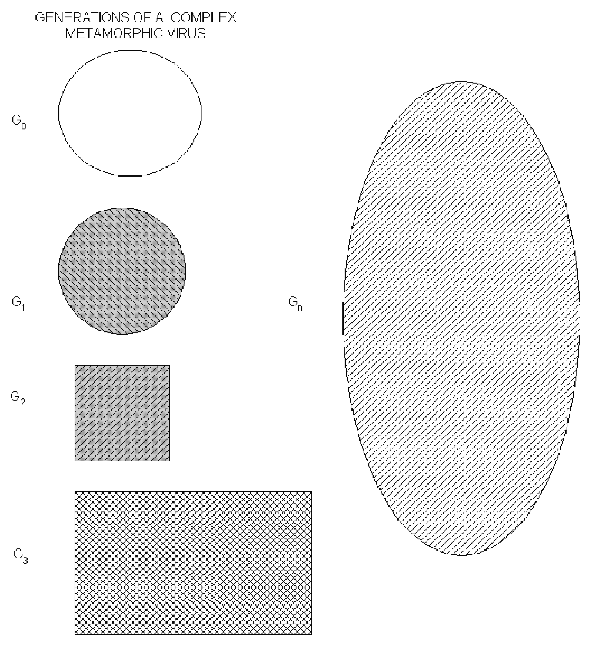
Figure 1. Multiple shapes of a metamorphic virus body [20]

2.2.4.1 Register Swap

Register swapping is one of the simplest metamorphic technique. It mutates the virus body by swapping the operand registers with different registers. For example, instruction “pop edx” might be replaced with “pop eax.” The W95/Regswap virus [7] is among the early metamorphic viruses to use this technique. With register swapping, the opcode sequence remains unchanged, as shown in Figure 2.
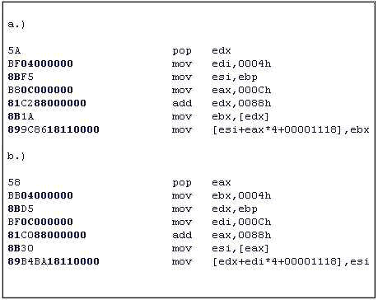
Figure 2. Two different generations of RegSwap [9]

Register swapping is a relatively weak form of metamorphism. Viruses such as RegSwap can be detected by using wildcard strings in a standard signature scan [19].

2.2.4.2 Subroutine Permutation

Subroutine permutation technique changes the appearances of a virus by reordering the subroutines. If a virus has n different subroutines, then we can generate n! distinct copies using subroutine permutation. The W32/Ghost virus [19] incorporates this technique. This particular virus has 10 subroutines and, therefore, it can generate 10! (or 3,628,800) unique copies. However, the virus can still be detected with search strings [19], as the content of each subroutine remains constant.

2.2.4.3 Garbage Instruction Insertion

Many metamorphic viruses incorporate the technique of garbage instruction insertion [2]. Garbage instructions are instructions that are either not executed (dead code) or have no effect (do nothing) on program outcomes [13]. By inserting garbage instructions at random within the useful instructions, a virus can generate an unlimited number of unique copies.

Examples of “do nothing” instructions are “nop,” “add R 0”, or “sub R 0”, where R is any register [6]. Dead code instructions often require inserting “jump” instructions to point to avoid executing the dead code. Any instructions between the “jump” instructions and the target of the jump will not be executed. The Win95/Zperm virus is one of the viruses that incorporate this technique. As illustrated in Figure 3 [19], the Win95/Zperm family of viruses creates new mutations by reordering core instructions and inserting jump and garbage instructions.

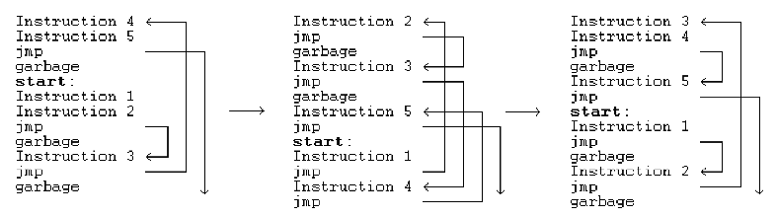
Figure 3. Zperm virus [19].

2.2.4.4 Instruction Substitution

Instruction substitution is another common technique for generating metamorphic viruses. Instruction substitution is the replacement of an instruction or a group of instructions with an equivalent instruction or group [15]. For example, “inc eax” is equivalent to “add eax, 1,” and as another example, “move eax, edx” can be replaced by “push edx” followed by “pop eax.” The W32/MetaPhor virus incorporates the instruction substitution technique. Some examples of instruction substitution used by the W32/MetaPhor virus [19] appear in Table 1.
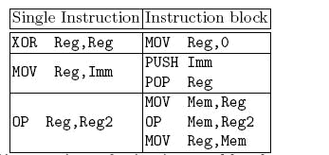
Table 1. Examples of instruction substitution used by W32/MetaPhor virus [19]

2.2.4.5 Transposition

Transposition is the reordering of the instruction execution sequence. This can only be done if the affected instructions have no dependencies. Consider the following example from [24]:
op1 [r1] [, r2]
op2 [r3] [, r4] ; here r1 and/or r3 are to be modified

We can swap the above two instructions only if:
      - r1 not equal to r4; and
      - r2 not equal to r3; and
      - r1 not equal to r3.

2.2.5 Formal Grammar Mutation

Formal grammar mutation is the formalization of code mutation techniques by means of formal grammars and automatons [10]. In general, classic metamorphic generators can be presented as bulky, non-deterministic automata, because all possible input characters are specified for each state of the automata [10]. By formalizing existing code mutation techniques into formal grammars, one can then apply formal grammar rules to create new viral copies with great variations. Using this approach, a simple polymorphic decryptor code, as shown in Figure 4, can generate a new viral copy that looks very different than the original copy; see Figure 5.

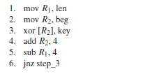
Figure 4. Simple polymorphic decryptor
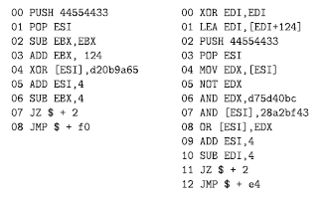
Figure 5. Generated polymorphic decryptor

Similarity and Hidden Markov Models

This section outlines the similarity test and the HMM technique developed in [2] for detecting metamorphic viruses.

3.1 Similarity Test

Metamorphism is, arguably, the best approach to evade signature detection. However, for this to be effective, different generations of a virus must be sufficiently different so that no common signature is present. Some virus creation toolkits come with the ability to generate morphed versions of the same virus, even from identical initial configurations. The similarity test in [2] provides a useful measure of the effectiveness of a metamorphic virus generator. In this section, we outline the steps used in computing this similarity index and we give examples that illustrate its significance.

3.1.1 Similarity Test Method

The similarity test in [2] was originally developed in [11]. This method compares two assembly programs and assigns a score as a percentage⎯a 0% result implies no similarity, while a 100% score implies the programs are virtually identical. This method is outlined below and illustrated in Figure 6.

- Given two assembly programs, X and Y, first extract the sequence of opcodes for each of the programs, excluding operands, comments, blank lines, labels, and other directives. The result is two opcode sequences, one of length n and one of length m, where n and m are the number of opcodes in programs X and Y, respectively. Each opcode is assigned an opcode number: the first opcode is 1, the second is 2, and so on.

- Compare the opcode sequences by considering all subsequences of three consecutive opcodes from each sequence. Count as a match any case where all three opcodes are the same in any order. A mark will be placed on a graph coordinate (x, y) of the match, where x is the opcode number of the first opcode of the three-opcode subsequence in program X, and y is the opcode number of the opcode subsequence in program Y.

- After comparing the entire opcode sequences and marking all the match coordinates, a graph plotted on a grid of dimension n × m is obtained. Opcode numbers of program X are represented on the x-axis and those of program Y are represented on the y-axis. To remove noise and random matches, only those line segments of length greater than some threshold values (e.g., five) will be retained.

- Identical segments of opcodes in X and Y will form line segments parallel to the main diagonal (if n = m, the main diagonal is simply the 45 degree line). If a line segment falls on the main diagonal, the matching opcodes are at identical locations in the two opcode sequences. A line off the diagonal indicates that the matching opcodes appear at different locations in the two files.

- For each axis, the sum of the number of opcodes that are covered by one or more line segments is calculated. This number is divided by the respective total number of opcodes (n for the x axis and m for the y axis) to give the percentage of opcodes that match some opcodes in the other program. The similarity score for the two programs is the average of these two percentages.

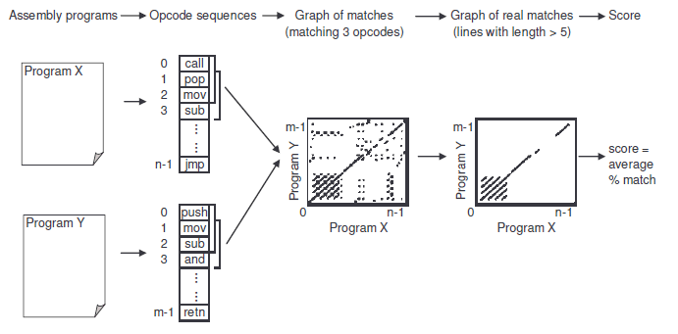
Figure 6. Process of finding the similarity between two assembly programs [2]

3.1.2 Similarity Test Results

Upon the completion of the similarity test, a graph is generated to visualize the results. Usually, a graph generated by plotting all of the matches for file X and Y (see Figure 7-a) is relatively dense due to random matches, which makes it difficult to visualize the similarity. A more useful graph is obtained by deleting all matches that are less than a specified threshold. Figure 7-b shows a graph that is generated with threshold of five. Previous studies in [2] have shown that the best metamorphic engine (NGVCK) achieves a similarity score of about 10%, whereas a control set of normal files are shown to have a similarity of about 30%.

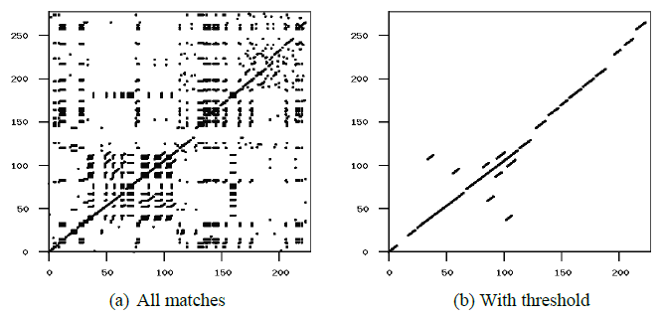
Figure 7. Similarity graph [2]

3.2 Hidden Markov Models

Hidden Markov Models (HMM) are statistical pattern analysis algorithm. The notations used in the HMM are as follows:

T = Length of the observed sequence
N = Number of states in the model
M = number of distinct observation symbols
O = Observation sequence {O₀, O₁, …, O_{T-1}}
A = State transition probability matrix
B = Observation probability distribution matrix
π = Initial state distribution matrix
A generic Hidden Markov Model is illustrated in Figure 8. The state and observation at time t are represented by X_{t} and O_{t} respectively. An underlying Markov process—which is hidden behind the dashed line—is determined by the initial state X₀ and the A matrix. Only the O_{i} are observable, and these observations are related to the hidden states of the Markov process by the matrix B. The matrices A and B are both row stochastic, that is, each row is a probability distribution.
Figure 8. Generic Hidden Markov Model [14]

HMMs are widely used for protein modeling and speech recognition applications [3]. An HMM can be used to create a model based on training data. The trained model can then be used to score data to determine its similarity to the training data.

Recently, HMMs have been successfully used to detect metamorphic viruses [2, 9]. Although metamorphic engines use varies code obfuscation techniques to change the appearance of their viral copies, some statistical patterns exist within a virus family. An HMM can be trained using opcode sequences extracted from known family viruses. Subsequently, any file can be scored using the model to determine if it belongs to the virus family or not.

3.2.1 HMM Example

A simple example in [14] illustrates the inner working of an HMM. Suppose that we have no prior knowledge of the average annual temperature for some given years in the past, but we know that tree ring size is correlated with temperature. We observe tree ring sizes for the years in question and record these as small (S), medium (M) or large (L). To keep the example simple, we assume that the annual temperature can be either hot (H) or cold (C). In addition, we know that the probability of a hot year followed by another hot year (HH) is 0.7; a hot year followed by a cold year (HC) is 0.3; a cold year followed by a hot year is 0.4; and a cold year followed by another cold year is 0.6. Figure 9 shows the matrix representation of these probabilities.
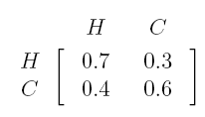
Figure 9. Temperature transition probability

Furthermore, we know that the correlation between tree sizes and temperature is as follows:
—In a hot year, the probability of a small tree ring is 0.1, medium is 0.4, and large is 0.5.
—In a cold year, the probability of a small tree ring is 0.7, medium is 0.2, and large is 0.1.
Figure 10 shows this correlation between temperatures and tree ring sizes in a matrix form.
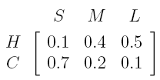
Figure 10. Tree size probability

In this example, the annual temperatures are the states, and the tree sizes are the observations. The probability of different tree sizes at each temperature represents the probability of the observation symbols in each state. The underlying states of the Markov process (H and C) are hidden, since the temperature in the past cannot be observed directly. We can, however, observe the tree ring sizes (S, M, and L) for the years of interest, and these are statistically related to the hidden states. With the given knowledge of correlation probabilities for annual temperature and tree sizes, we can build an HMM model as shown in Figure 11.
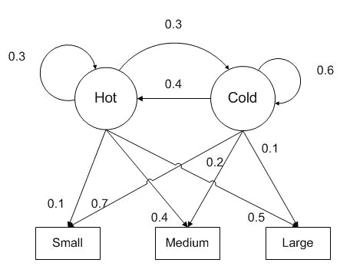
Figure 11. HMM model [14]

Suppose we observe that tree ring sizes for four consecutive years are (S, M, S, L). We next show that we can use this observed sequence to find the most probably annual temperature sequence.

To solve this problem we first construct our HMM parameters as follows:
—State transition probability matrix
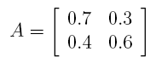
—The observation probability distribution matrix
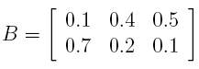

—Number of states in the model N = 2 (hot and cold)

—Number of distinct observation symbols M = 3 (small, medium, and large)

—Given initial state distribution matrix
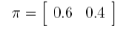

The initial distribution matrix, π, gives the initial probability of being in a hot or cold state. Given this information, the following steps can be used to determine the most likely states corresponding to the given observation sequence (S, M, S, L), which is of length T=4.

- Determine all possible state transitions = N^{T}.
- Calculate the probability of a given observation sequence for each state transition from step 1. For example,

P(HHCC) = πH * bH(S) * aH,H * bH(M) * aH,C * bC(S) * aC,C * bC(L)
= (0.6) * (0.1) * (0.7) * (0.4) * (0.3) * (0.7) * (0.6) * (0.1)
= 0.000212

The results for all possible state sequences are given in Table 2.

- The most likely annual temperature sequence is the one with the highest probability. In this case, CCCH has the highest probability.

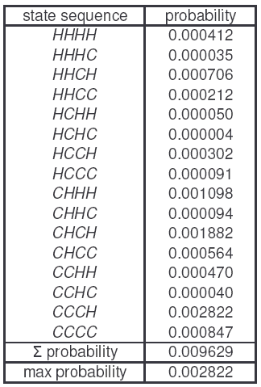
Table 2. Probabilities of observing (S, M, S, L) for all possible state sequences [14]
The above brute-force method of computing the desired results requires an exponential amount of work, which is generally infeasible. The strength of the HMM approach is that efficient algorithms exist to solve this and related problems. The three HMM problems of interest are the following [14]:

      - Given the model λ = (A, B, π) and an observation sequence O, find P(O | λ). That is, given a model, we can score an observation sequence.

      - Given the model λ = (A, B, π), find an optimal state sequence for the underlying Markov process. That is, we can uncover the “hidden” part of the HMM.

      - Given an observation sequence O, the number of symbols M, and the number of states N, determine the model λ = (A, B, π) that maximizes the probability of O. In other words, a model can be trained that best fits the observed data.

The fact that there are efficient algorithms for solving the three HMM problems provides the basis for a tool for virus detector. Specifically, we train a model using extracted opcodes (problem 3), then we use the resulting model to score executable file (problem 1) to determine the likelihood that they are viruses. For more details on HMMs, see the expository article [14].

3.2.2 HMM as Virus Detection Tool

To use HMMs as a virus detection tool requires training data to produce a model. The goal is to train an HMM to represent the statistical properties of a given virus family. The trained model can then be used to determine whether a given program is similar to the viruses in the training set. A model is trained by collecting training data from files generated by the same metamorphic generator. This also means that the resulting model is specific to the generator from which the training data originated.

To produce an HMM model, a set of viruses from the same generator are disassembled using IDA Pro [22]. The opcode sequences found in these files constitute the observations. A long observation sequence is formed by concatenating all of these virus file opcodes. An HMM training model is then constructed using the solution of the third HMM problem discussed above. For example, given the training data in Figure 12, the corresponding HMM model is shown in Figure 13. Note that only the initial part of the training sequence appears in Figure 12 and only the initial section of the B matrix appears in Figure 13.

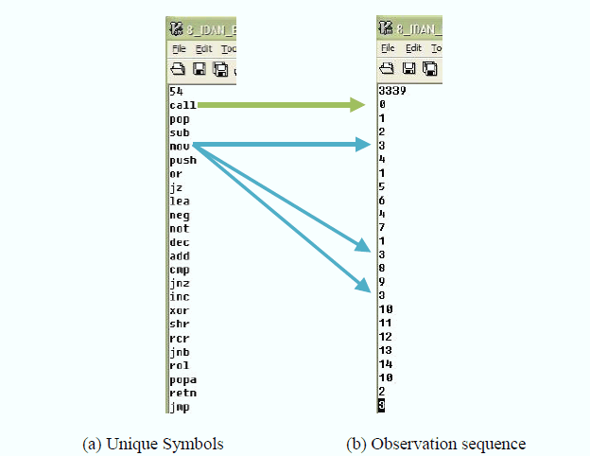
Figure 12. Training data example [5]
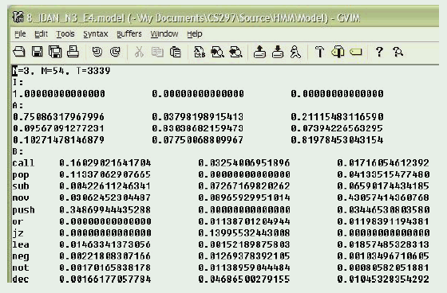
Figure 13. HMM model example [5]
After the HMM model is produced, it can then be used to test any file to determine if it belongs to the same virus family from which the training data was obtained. If a file has a score greater than a certain threshold, then it is assumed to belong to the same family; otherwise, it is not in this family. The threshold is determined experimentally. An example of HMM output is shown in Figure 14. With this particular example, IDAN0 through IDAN4 are in the same virus family as the HMM model while IDAR0 through IDAR4 are not in the same virus family.
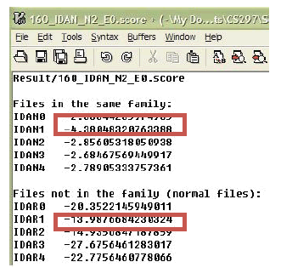
Figure 14. HMM result example [5]

Implementation

4.1 Introduction

To produce viral copies that are hard to detect, a metamorphic engine needs to implement many code obfuscation techniques. The HMM detector developed in [2] was able to correctly classify the family viruses and normal code with 100% accuracy for every virus generator tested. Our goal here is to create a metamorphic generator that evades signature detection and also is undetectable by the HMM-based approach in [2]. The paper [5] contains a highly metamorphic generator that was designed to evade HMM detection. However, the approach in [5] was largely unsuccessful at evading HMM-based detection, which indicates that the HMM approach is very effective in detecting highly morphed viruses. Our goal is to build on the work in [5] to create an “undetectable” metamorphic generator.

4.2 Goals

Our metamorphic generator is geared toward achieving the following goals:

• Generate morphed copies of a single input virus. These morphed copies should have a similarity of approximately 30% or less with the base virus and among themselves.
• The morphed copies should have the same functionality as the base virus. Based on the work in [2] and [5], this level of similarity will enable the viruses to evade signature detection.
• The morphed copies should be “close” to normal programs. For our purposes, the normal programs are cygwin utility files of roughly the same size as the base virus. The reason for using cygwin utility files is that they are typically engaged in similar same low-level operations as viruses. A morphed virus is “close” to a normal program if its statistics, such as its opcode counts, are closer to those of the normal files than those of a the original seed virus. If the morphed viruses are “close enough” to the normal files, they should evade HMM detection. The notion of “close” will be discussed in greater detail in the next section.
• Ideally, the metamorphic engine should work on any assembly program.

In short, our goal is to generate viral copies that evade signature detection and also evade HMM detection. This is the precise sense in which our viruses are “undetectable”.

4.3 Code Obfuscation Techniques

Our metamorphic engine leverages the code obfuscation techniques implemented in [5] with some important refinements. The engine in [5] applies code obfuscation techniques essentially at random. This randomness does not make the virus “close” to a normal program. In our engine, we will apply a randomly-selected code obfuscation only if it makes the virus look more like a normal program. We have developed a simple scoring algorithm, namely our Dynamic Scoring Algorithm, for efficiently comparing the virus code with a normal program.

4.3.1 Dynamic Scoring Algorithm

To make a virus similar to a normal file, we developed an algorithm to calculate the score of similarity between two files⎯the lower the score, the better the match. Since this algorithm will need to run each time we try to change an instruction, it must be as efficient as possible.
The Dynamic Scoring Algorithm developed in this project need not compute the score from scratch each time. Instead, it modifies the score based on the actual modifications made.

4.3.1.1 Algorithm Initialization

To initialize the dynamic scoring algorithm, two files will be passed into it as parameters. The first one is a virus, and the second one is a normal file.

Algorithm initialization will generate four master lists: individual opcode counts of the virus file; opcode-pair counts of the virus file; individual opcode counts of the normal file; and opcode-pair counts of the normal file. For example, given two short files with five opcodes, as shown in Table 3, the initializing of the algorithm will generate four lists, as shown in Table 4.
Virus opcode | Normal file opcode
Mov | Mov
Add | Mov
Mov | Sub
Pop | Pop
Retn | Retn
Table 3. Opcode sequences of virus file and normal files

Virus opcode count list | Normal file opcode count list | difference | Virus opcode-pair count list | Normal file opcode-pair count list | difference
Mov (2)  Add (1)  Pop (1)  Retn(1)  Sub (0) | Mov (2)  Add (0)  Pop(1)  Retn(1)  Sub (1) | 0  1  0  0  1 | Mov_add (1)  Add_mov(1)  Mov_pop(1)  Pop_retn(1)  Mov_mov(0)  Mov_sub(0)  Sub_pop(0) | Mov_add (0)  Add_mov(0)  Mov_pop(0)  Pop_retn(1)  Mov_mov(1)  Mov_sub(1)  Sub_pop(1) | 1  1  1  0  1  1  1
Table 4. Opcode and opcode-pair counts lists

We compute the initial score by summing the difference of the opcode counts and the opcode-pair counts. In the example above, the initial score is 8.

4.3.1.2 Scoring the Changes

To determine whether a change will yield a better score, we only need to compute the score change in terms of the opcode sequence changes. Using the old sequence and the new sequence as input, a score less than 0 means the change would make the two files closer to each other, while a score greater than 0 means the change would make the two files less similar to each other. A score of 0 means no change.

For example, when we transpose “add, mov” to “mov, add,” we will pass the original subsequence and the new subsequence that includes one opcode before and one opcode after, in addition to the proposed change itself. In this example, suppose the two subsequences pass to the scoring changes method are “mov, add, mov, pop” (original subsequence) and “mov, mov, add, pop” (new subsequence).

We then compute the changes in scores as follows:

- Compute and save the to-be-affected counts.
- Subtract the counts of the original subsequence from the master lists.
- Add the counts of the new subsequence to the master lists.
- Compute the affected counts against the normal file.

Table 5 shows the result of computing the score (5 in this case).

To-be-affected Virus opcode count list | Normal file opcode count list | Difference before changes | To-be-affected Virus opcode-pair count list | Normal file opcode-pair count list | Difference before changes
Mov (2)  Add (1)  Pop (1) | Mov (2)  Add (0)  Pop(1) | 0  1  0 | Mov_add (1)  Add_mov(1)  Mov_pop(1)  Mov_mov(0) | Mov_add (0)  Add_mov(0)  Mov_pop(0)  Mov_mov(1) | 1  1  1  1
Table 5. Saved original subsequence score

Table 6 shows the subtraction and addition of the original subsequence and new subsequence. The final subsequence counts and the relative normal file counts are show in Table 5. The new score is also reflected as a difference in Table 7. Note that “Add_pop” is a new counter.

Subtract original subsequence | Add new subsequence |  | Subtract original opcode-pair count list | Add new subsequence opcode-pair count
Mov (2-2=0)  Add (1-1=0)  Pop (1-1=0) | Mov (0+2=2)  Add (0+1=1)  Pop(0+1=1) |  | Mov_add (1-1=0)  Add_mov(1-1=0)  Mov_pop(1-1=0)  Mov_mov(0) | Mov_add (0+1=1)  Add_mov(0+0=0)  Mov_pop(0+0=0)  Mov_mov(0+1=1)  Add_pop(1)
Table 6. Subtract from old count and add new count

New Virus opcode count list | Normal file opcode count list | Difference after changes | new Virus opcode sequence count list | Normal file opcode sequence count list | Difference after changes
Mov (2)  Add (1)  Pop(1) | Mov (2)  Add (0)  Pop(1) | 0  1  0 | Mov_add (1)  Add_mov(0)  Mov_pop(0)  Mov_mov(1)  Add_pop(1) | Mov_add (0)  Add_mov(0)  Mov_pop(0)  Mov_mov(1)  Add_pop(0) | 1  0  0  0  1
Table 7. New score after changes
As shown in Table 7, the new score of the affected subsequence is 3, and the original score is 5 (shown in Table 5). This tells us that if we do make this change, we will make the virus file “closer” to the normal file by 2 points.

4.3.1.3 Updating the Changes

If the score improves, then we update the virus. Continuing with the example in the previous section, we make the change in Table 8.

Virus opcode count list | Normal file opcode list | difference | Virus opcode-pair count list | Normal file opcode-pair list | difference
Mov (2)  Add (1)  Pop (1)  Retn(1)  Sub (0) | Mov (2)  Add (0)  Pop(1)  Retn(1)  Sub (1) | 0  1  0  0  1 | Mov_add (1)  Add_mov(0)  Mov_pop(0)  Pop_retn(1)  Mov_mov(1)  Mov_sub(0)  Sub_pop(0)  Add_pop(1) | Mov_add (0)  Add_mov(0)  Mov_pop(0)  Pop_retn(1)  Mov_mov(1)  Mov_sub(1)  Sub_pop(1)  Add_pop(0) | 1  0  0  0  0  1  1  1
Table 8. Updated opcode count lists

4.3.2 Dead Code Insertion

Instruction frequencies in a base virus are generally statistically different than those in normal programs. Previous work [5] has analyzed the statistics of virus instructions versus normal program instructions. These statistics appear in Figure 15 and Figure 16.

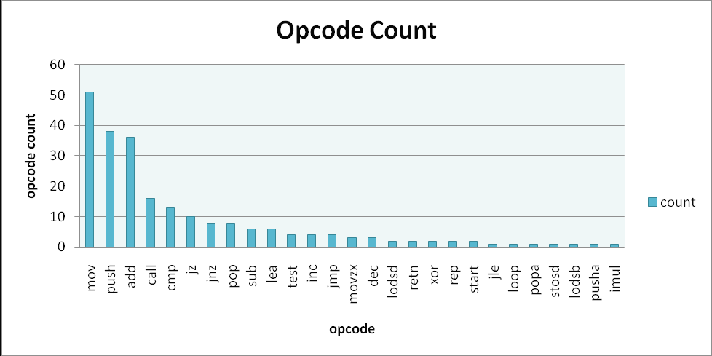
Figure 15. Base virus opcodes and their frequencies [5]

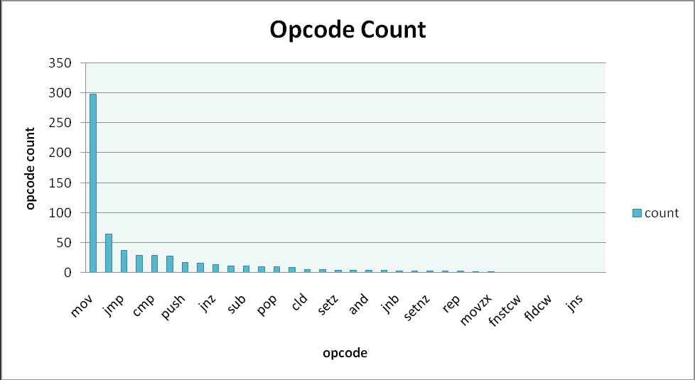
Figure 16. Opcodes of normal files and their frequencies [5]

To make our base virus more like a normal program, we insert some dead code into the generated viruses. However, the set of dead code that we built into our engine is finite. Applying this dead code excessively might enable heuristic detection (or HMM detection). Therefore, we will also generate “dead code” on the fly by copying blocks of instructions and subroutines from the selected normal program. Since the dynamically generated “dead code” is, in fact, actual code from the normal program, using this code will make our viruses look more like normal programs.

4.3.2.1 Inserting Dead Code

Our engine employs the dead code library from [5]. However, instead of randomly inserting dead codes, we will only insert dead code from our library if that makes our virus more like a normal program. Our dead code insertion algorithm is shown in Figure 17.
For each instruction
      - Insert dead code before and/or after it.
      - Compute a score using the Dynamic Scoring Algorithm.
      - If the score is better or remains the same, keep the changes and update the Dynamic Scoring Algorithm counters.
      - If the score worsens, discard the change made in step 1.

Figure 17. Dead code insertion algorithm

4.3.2.1 Inserting Dead Code Generated from a Normal File

The instructions that we copy from a normal file are blocks of five or more continuous instructions, or complete subroutines. When we copy a block of continuous instructions, we will insert an unconditional “jmp” instruction before the block so that these instructions will not be executed. In addition to inserting a jump instruction, we might also need to modify the operands of some instructions so that the generated virus assembly file can be assembled correctly [21]. For example, if an instruction contains a label that is only valid in the normal file, then we will need to replace that label with a label that is valid in the generated virus file.

When copying a subroutine, we also need to modify the operands of some instructions. However, we do not need to insert jump instructions. The copied subroutine will be placed between two subroutines in the virus file. Since the copied subroutine never gets called, it will not impact the behavior of the virus.

4.3.3 Equivalent Instruction Substitution

Some opcodes, such as mov, push, and add instructions, appear more frequently in our base viruses as compared to our normal files [5]. To make the generated virus opcode count statistically closer to normal programs, we substitute equivalent instructions. For example, “add instruction” can be replaced with “sub,” “lea,” or “not,” followed by “neg” instructions, as shown in Table 9.

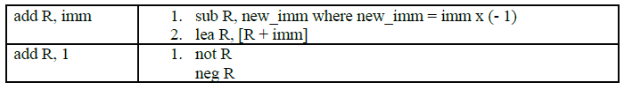
Table 9. Equivalent instructions for add [5]

While substituting equivalent instructions, we also keep track of the score changes between virus copies and normal files. We only perform substitution if the score improves. Our algorithm for equivalent instruction substitution is shown in Figure 18.

For each instruction
      - Perform substitution if possible.
      - Compute a score using the Dynamic Scoring Algorithm.
      - If the score improves or remains the same, keep the change and update the Dynamic Scoring Algorithm counters.
      - If the score worsens, discard the change made in step 1.

Figure 18. Equivalent instruction substitution algorithm

4.3.4 Transposition

After generating dead code and performing equivalent instruction substitution, we perform transposition, again, to make our viruses closer to the normal program. The transposition algorithm in [5] performs transposition randomly with a probability of 25%. We removed the randomized nature of that algorithm. Instead, we used the Dynamic Scoring Algorithm to perform transposition in order to make our virus closer to a normal program. Our transposition algorithm is as shown in Figure 19.

      - Read two instructions with two operands.
      - To perform transposition:
  - Read third instruction
  - If the third instruction is not any conditional jump instruction then
    - If the to-operands of both instructions are not equal
And
If the to-operand of the first instruction is not equal to the from-operand of the second instruction
And
If the from-operand of the first instruction is not equal to the to-operand of the second instruction
Then
Swap the two instructions.
- Compute the score of the transposition.
- If the score improves, keep the change. Otherwise, discard the change.

Figure 19. Transposition algorithm

4.4 Metamorphic Engine Algorithm

The code obfuscation techniques described in Section 4.3 are implemented as individual modules in our engine. We execute each module in sequence to generate our final virus copy. The overall engine algorithm is shown in Figure 20 below:

      - Read in a base virus and a normal file.
      - Initialize the Dynamic Scoring Algorithm.
      - Insert dead code between each instruction if it makes the virus “closer” to the normal file.
      - Perform equivalent instruction substitution for each instruction if it makes the virus closer to the normal file.
      - Perform transposition for every instruction pair if it makes the virus closer to a normal file.
      - For each instruction, generate a random number between 0 and 99:
        - If random number < configured percentage for junk block, copy a junk block from normal file.
      - Between each subroutine, generate a random number between 0 and 99.
        - If random number < configured percentage for junk function, copy a subroutine from normal file.

Figure 20. Metamorphic engine algorithm

Experiments

We used the similarity algorithm and HMM detection tools developed in [2] to perform our tests. After we successfully demonstrated that our engine was able to escape HMM-based detection, we repeated our test with different engine settings to find the threshold at which the HMM detector began to fail.

5.1 Base Virus

To test our engine, we first used NGVCK to generate 200 virus files of the same family. These 200 virus files served as our base viruses. We then constructed 40 normal files from cygwin utility files.

After we generated our base viruses and normal files, we used the HMM detector to verify that viruses generated by NGVCK were still detectable. The procedures we executed with the HMM detector are the same as those in [2]. We first generated the HMM model with 160 viruses. We then generated the scores for the remaining 40 viruses against the HMM model. We also generated the scores for the 40 normal files against the same HMM model.

If none of the normal files score higher than the viruses, then the HMM detector will detect the family viruses without fail. On the other hand, if some normal files score higher than some of the virus files, then the HMM detector will not have a clear threshold for determining whether a given file is a virus or not. This means that some viruses will escape HMM-based detection.

Figure 21 shows the result of scoring base viruses against normal files. All of the normal files score lower than virus files. Therefore, the base viruses we generated from NGVCK are detectable by the HMM detector. This is a repetition of the work in [2].

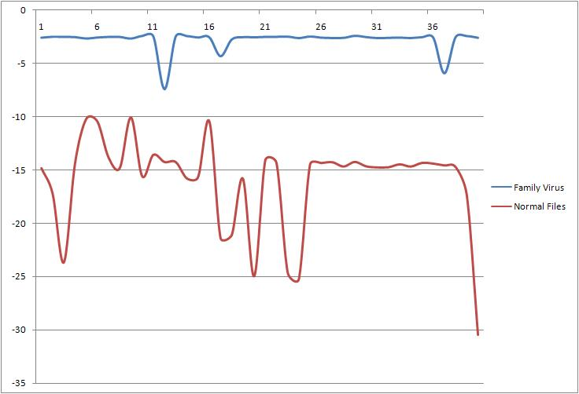

Figure 21. HMM results for base viruses generated by NGVCK

After we generated base viruses, we used our engine to perform additional code obfuscation. Our engine takes one base virus and one normal file as inputs. It applies additional code obfuscation techniques to the base virus so that the generated virus copy will be statistically closer to a normal file.

5.2 Similarity Test

The similarity test compares and reports the percentage of similarity between two assembly programs [5]. Since our engine will make a virus file closer to a normal file, we will compare the similarity of a virus file with its peer normal file as we increase the percent of dead code copied from the normal file.

We first compared a base virus against a normal file, and there was essentially no similarity between them at all. Then we ran the two files through our engine without any dead code copying and we obtained a similarity score of 13.8% between the two files. This similarity graph is given in Figure 22.

Figure 22. Similarity score for morphed virus against normal files

Then we copied dead code from the normal file into the virus and computed the similarity score again. As expected, the more dead code we copied from the normal file into the virus, the higher the similarity score; see Figure 23. Since dead code blocks copied from the normal file were of different sizes, we use the file size for the x-axis of our graph in Figure 23, and for the remainder of the graphs in this paper. As expected, when more dead code is added to the virus file, the similarity score between the virus and normal files generally increased.

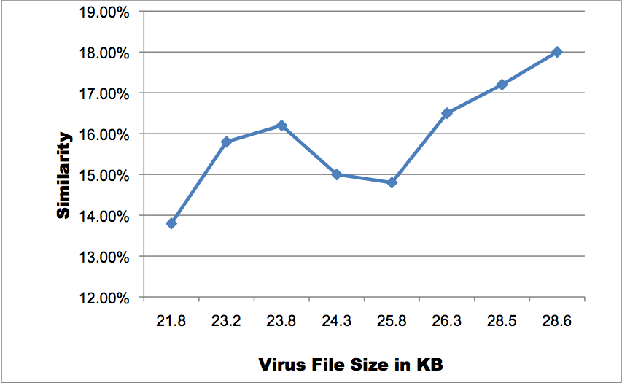

Figure 23. Similarity score of virus and file size

5.3 HMM-based Detection

We performed HMM tests for each set of viruses that we generate. The idea is to see how much dead code we need to copy from normal files to make our viruses undetectable using this HMM approach.

We executed HMM tests on our viruses with the number of hidden states ranging from 2 to 5. However, based on the previous work [2, 5] (confirmed by our results), it appears that the number of hidden states will not significantly affect the results. Therefore, we will focus on analyzing the results for the HMM tests with three hidden states; see [25] for tests involving other numbers of hidden states.

5.3.1 Zero Percent Dead Code

This set of viruses was generated by applying our engine without any dead code copied from the normal files. With this setting, the average file size increase from 17KB to 21.8KB. The similarity score also increase from 0% to 13.8%. From the results in Figure 24, we see that detection is possible in this case.

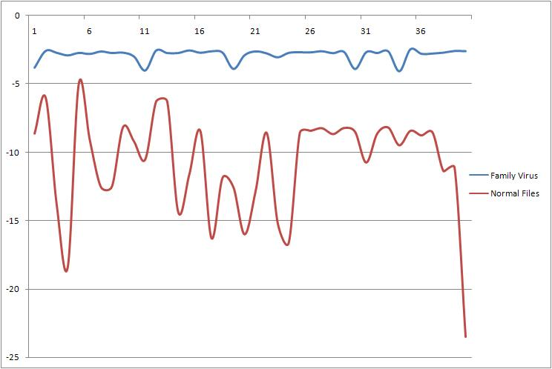
Figure 24. HMM result with 0% dead code copied

5.3.2 Copying Blocks of Dead Code from Normal File

This next set of viruses was generated by applying our engine with a probability of 10% to 35% for copying dead code blocks into the viruses after each virus instruction. With this setting, the average file size increased from 17KB to 24.3KB. The HMM results for this case are shown in Figure 25.

In spite of these high settings for dead code insertion, the HMM was able to distinguish the family virus. These strong detection results are, perhaps, somewhat surprising given that the dead code was carefully selected so as to increase the similarity between virus and the normal files.

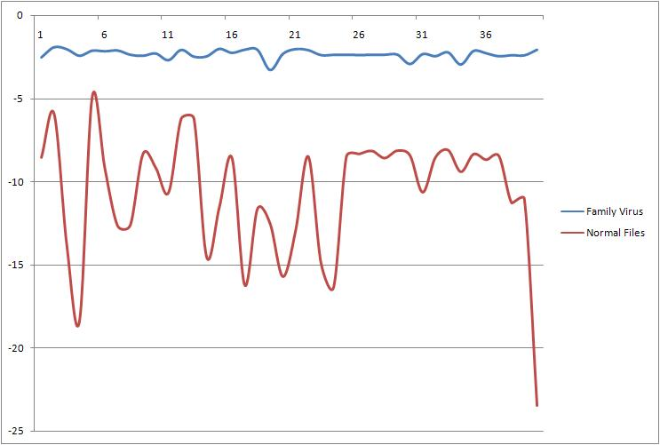
Figure 25. HMM results with 35% dead code copied

5.3.3 Copying Subroutines from Normal File

We continued our experiment by copying subroutines from the normal files into our viruses. We first configured the subroutine copying probability to 5% and ran our test and we then repeated our tests with subroutine copying probabilities of 15%, 20%, and 30%.

Even with a probability of 5%, the HMM-based detection started to fail. That is, we see some viruses score lower than the maximum score of the normal files. Figure 26 gives the scores of family viruses and normal files against the HMM model. Sixteen viruses score lower than the maximum normal file score. This means that if the HMM threshold is set to the maximum normal file score, 16 viruses will be undetectable by the HMM. On the other hand, if the HMM threshold is set to the minimum virus file score, then three normal files will be classified as viruses. These levels of failure would make the HMM entirely impractical as a detection tool for this metamorphic virus family.

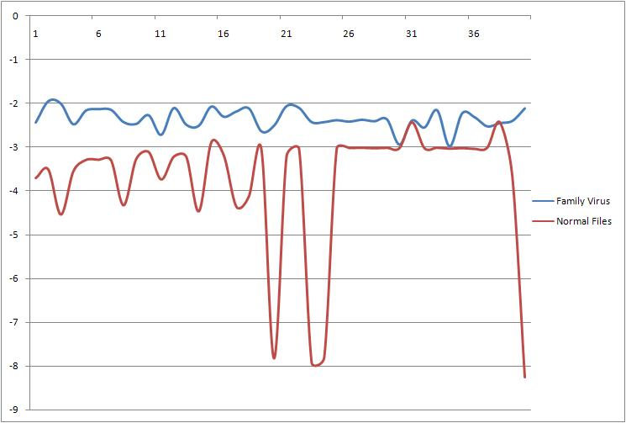
Figure 26. HMM result with 35% dead code blocks and 5% subroutine copied

5.3.4 Copying Subroutines Only from Normal File

Based on the results shown in the previous section, we observed that copying subroutines from normal files significantly impacted our scores. Therefore, we conducted additional experiments copying only subroutines into our base viruses without additional code obfuscation. These results showed that even with as little as a 5% threshold for copying subroutines from the normal files, the HMM detector misclassified some of our viruses; see Figure 27.

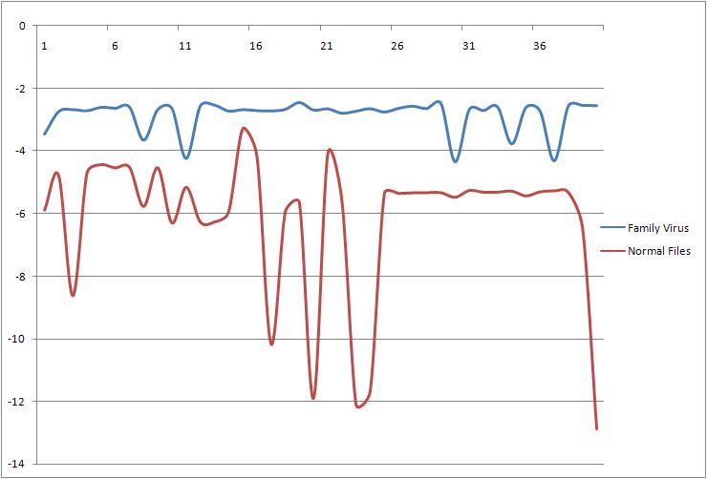
Figure 27. HMM results with 5% subroutine copied

Additional experimental results can be found in [25].

Conclusions and Future Work

By making our viruses similar to normal files, we were able to make them undetectable using an HMM-based detector. The HMM-based detector began to fail when we copied 5% of subroutines from normal files. With our highest setting of 35% dead code blocks and 30% subroutines, most of the scores for viruses and normal files were indistinguishable from each other.

To evade signature detection, a metamorphic engine must generate highly metamorphic viruses, that is, the viruses must exhibit little similarity when compared to other viruses of the same family. However, in [2] it was shown that a high degree of metamorphism is not sufficient to evade HMM-based detection, and it was conjectured that highly metamorphic viruses that are similar to normal code would evade HMM-based detection. The work presented here confirms this conjecture, while also providing a simple method to obtain the required level of similarity. It is somewhat disconcerting that such a small addition of carefully selected code can defeat the HMM detector in [2], which heretofore had proven itself highly robust.

References
[1] M. Stamp, Information Security: Principles and Practice, Wiley, 2005.
[2] W. Wong and M. Stamp, Hunting for metamorphic engines, Journal in Computer Virology, Vol. 2, No. 3, December 2006, pp. 211–229
[3] S. Attaluri, S. McGhee and M. Stamp, Profile hidden Markov models and metamorphic virus detection, Journal in Computer Virology, Vol. 5, No. 2, May 2009, pp. 151–169
[4] P. Szor, The Art of Computer Virus Defense and Research, Symantec Press 2005.
[5] P. Desai, “Towards an Undetectable Computer Virus,” Master’s thesis, San Jose State University, 2008. http://www.cs.sjsu.edu/faculty/stamp/students/Desai_Priti.pdf
[6] Orr, “The Viral Darwinism of W32.Evol: An In-depth Analysis of a Metamorphic
eEgine,” 2006. http://www.antilife.org/files/Evol.pdf
[7] Orr, “The Molecular Virology of Lexotan32: Metamorphism Illustrated,” 2007. http://www.antilife.org/files/Lexo32.pdf
[8] E. Konstantinou, “Metamorphic Virus: Analysis and Detection,” January 2008.
[9] A. Venkatesan, “Code Obfuscation and Metamorphic Virus Detection,” Master’s report, Department of Computer Science, San Jose State University, 2008. http://www.cs.sjsu.edu/faculty/stamp/students/ashwini_venkatesan_cs298report.doc
[10] P. Zbitskiy, Code mutation techniques by means of formal grammars and automatons, Journal in Computer Virology, Vol. 5, No. 3, August 2009, pp. 199–207
[11] P. Mishra, “A Taxonomy of Software Uniqueness Transformations,” Master’s report, Department of Computer Science, San Jose State University, 2003. http://www.cs.sjsu.edu/faculty/stamp/students/FinalReport.doc
[12] J. Aycock, Computer Viruses and Malware, Springer, 2006
[13] E. Daoud and I. Jebril, Computer Virus Strategies and Detection Methods, Int. J. Open Problems Compt. Math., Vol. 1, No. 2, September 2008. http://www.emis.de/journals/IJOPCM/files/IJOPCM(vol.1.2.3.S.08).pdf
[14] M. Stamp, “A Revealing Introduction to Hidden Markov Models,” January 2004. http://www.cs.sjsu.edu/faculty/stamp/RUA/HMM.pdf
[15] Walenstein, R. Mathur, M. Chouchane, R. Chouchane, and A. Lakhotia, “The Design Space of Metamorphic Malware,” In Proceedings of the 2nd International Conference on Information Warfare, March 2007.
[16] Wikipedia, “Computer Virus,” May 2009, http://en.wikipedia.org/wiki/Computer_virus
[17] F. Cohen, “Computer viruses: theory and experiments,” Computer Security, 6(1):22-35, 1987
[18] “Benny/29A,” Theme: metamorphism, http://www.vx.netlux.org/lib/static/vdat/epmetam2.htm
[19] J. Borello and L. Me, Code Obfuscation Techniques for Metamorphic Viruses, Journal in Computer Virology, Vol. 4, No. 3, August 2008, pp. 211–220
[20] A. Lakhotia, Are Metamorphic Viruses Really Invincible?, Virus Bulletin, December 2005.
[21] FASM, http://flatassembler.net/
[22] IDA Pro, http://www.hex-rays.com/idapro/
[23] Wikipedia, “Heuristic analysis,” March 2009, http://en.wikipedia.org/wiki/Heuristic_analysis
[24] HowStuffWorks, Computer & Internet Security, May 2008, http://computer.howstuffworks.com/virus.htm
[25] D. Lin, Hunting for undetectable metamorphic viruses, Master’s report, Department of Computer Science, San Jose State University, 2010

