P2PTunes: A Peer-to-Peer Digital Rights Management System

Ramya Venkataramu
Hewlett-Packard Company
10955 Tantau Avenue
Cupertino, California

Mark Stamp
Department of Computer Science
San Jose State University
San Jose, California

Abstract
Digital Rights Management (DRM) technology is used to control access to copyrighted digital content. Apple employs a DRM system known as Fairplay in its iTunes online music store. Users communicate with the centralized iTunes server to download, purchase, play, and preview digital content. The iTunes music store has the potential disadvantage of a bandwidth bottleneck at the centralized server. Furthermore, this bandwidth bottleneck problem will escalate with increasing popularity of online music and other digital media, such as video. In this paper we analyze the Fairplay DRM system. Then we consider a modified architecture that can be employed over existing peer-to-peer (P2P) networks. Our new system, P2PTunes, is designed to provide the benefits of a decentralized P2P network while providing DRM content protection that is at least as strong as that found in Fairplay.
Keywords: Digital rights management, DRM, peer-to-peer networks, P2P, iTunes, Fairplay, P2PTunes

Introduction
The success of the Apple iPod and associated iTunes music store has made Apple, Inc., a dominant company in both the online media distribution business and the digital media player market (Chandak 2005). The iPod is a portable digital media player which supports the Advanced Audio Coding (AAC), the Moving Pictures Experts Group (MPEG-1) Audio Layer-3 (MP3), Waveform Audio (WAV), and Audible formats (Apple 2006). The iTunes online store allows users to purchase digital media content. A proprietary software application—also known as iTunes—is used to connect to the iTunes online store to download digital content. The iTunes software is used to manage play lists among computers and iPods, and to play digital content on Windows computers, Macintosh computers, and the iPod.

Fairplay is a digital right management (DRM) technology used to protect digital content purchased from the iTunes online store. As with most DRM systems, the purpose of Fairplay is to place restrictions on the uses of copyrighted content.

For DRM, the required level of protection is much different than in most typical security applications. Many security applications simply require that data be securely transmitted from point-to-point, and for such applications, standard techniques from the fields of cryptography and security protocols suffice (Stamp 2006). However, in DRM the situation is much different, since the protection (e.g., usage restrictions) must stay with the content after it has been successfully delivered to the legitimate recipient. This additional level of security required in DRM is often known as persistent protection (Stamp 2006), since some level of protection must persist after successful delivery of the bits.

In the DRM context, the legitimate recipient is a potential attacker and, consequently, achieving any meaningful level of persistent protection is not a trivial task. In fact, it is impossible to ensure persistent protection if the content is accessible on an open platform (such as a modern PC) where the recipient has full administrative privilege. Therefore, we cannot expect a level of security comparable to, say, cryptography from a DRM system such as Fairplay. Instead, the test for such a system is whether a successful business model can be built on top of the inherently weak DRM protection (Stamp 2003). By this criteria, Fairplay is a highly successful DRM system, in spite of the known attacks that we discuss in Section 3.

The iTunes online store and Fairplay DRM employ a centralized server to distribute content and enforce the persistent protection on downloaded media. Any content distribution system based on a centralized server model has the potential disadvantage of a bandwidth bottleneck. Furthermore, as the number of users accessing the online store grows and the size of digital content increases (video requires much more bandwidth than music) additional strain will be placed on the central server (Kalker, et. al., 2004).
We believe that the centralized iTunes online music service may be improved by redesigning it to operate within a peer-to-peer (P2P) network. Such a system would make more effective use of available storage and bandwidth, since a P2P system can harness idle storage and network resources from client machines that voluntarily join the network (Rodrigues, Liskov, and Shrira 2002).

Each node in a P2P network has roughly equivalent capabilities and can initiate or service requests. This is in contrast to a client-server model, such as iTunes, where only the central server may service requests. P2P systems have emerged as a popular way to share vast amounts of data since they offer the benefits of self-organization, load-balancing, fault-tolerance, and the ability to pool and harness large amounts of resources (Daswani, et. al., 2002). Additionally, P2P networks are highly scalable and relatively easy to deploy (Tanin, Nayar, and Samet 2005). However, current P2P networks are rife with copyright violations and other security risks such as viruses, spyware, and other unwanted software (Microsoft 2007). In this paper, we present a DRM system that can be deployed over a P2P network and our proposed system enforces the same or higher level of security as iTunes. Furthermore, our proposed system, which we call P2PTunes, can operate over existing P2P networks.

In this paper, we first focus on critically analyzing iTunes and its Fairplay DRM system. We need to understand the strengths and weaknesses of this system before we can consider ways to develop a practical, efficient, and secure iTunes-like system that can function in a P2P environment. Then we present the details of our design for a DRM system that has all of the advantages of a P2P system and provides DRM security that is as at least as strong as the highly successful Fairplay system.

This paper is organized as follows. Section 2 provides background on Apple’s Fairplay DRM and iTunes. We also present a brief overview of P2P networks. In Section 3, we discuss the proposed design and architecture for our system, P2PTunes. Section 4 briefly covers a prototype implementation of P2PTunes. Section 5 deals with the security features of P2PTunes and we analyze the strengths and weaknesses of our proposed system, relative to iTunes. Finally, Sections 6 and 7 contain conclusions and ideas for future work, respectively.

Background

2.1 MPEG-4
Fairplay DRM is built on top of QuickTime. The QuickTime file format is a “container” that can handle audio, video, images, text, and other digital formats (Apple 2006). In addition, QuickTime is adaptable—new capabilities can be added and new versions maintain backward compatibility (Apple 2006).
QuickTime is the file format of choice for Moving Pictures Experts Group (MPEG-4) standard. The MPEG-4 standard covers the entire spectrum of digital media tasks, including the capture, authoring, editing, encoding, distributing, playback, archiving, and delivery of professional-quality digital media. Since it is generally based on QuickTime, MPEG-4 inherits QuickTime’s stability, extensibility, and scalability (Apple 2006).
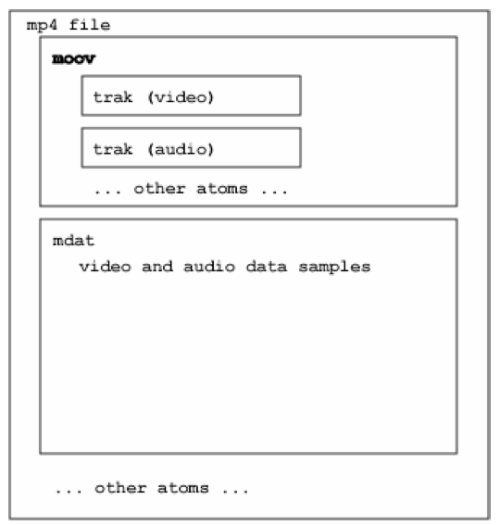
Figure 1: MPEG-4 File Structure (Anonymous 2006)

Advanced Audio Coding (AAC) is used in the audio layer of MPEG-4 files, since AAC compresses audio data more efficiently than older formats such as MP3 (Apple 2006). Apple uses Fairplay to encrypt the AAC-encoded audio data inside an MPEG-4 file, resulting in what is known as a protected AAC files. Protected files carry an m4p extension, while unprotected files are of type m4a.

MPEG-4 files are built up of atoms, each of which stores specific information pertaining to the digital content. Every atom has an 8-byte header indicating the atom type, followed by the corresponding data field. The atom type indicates how to process the atom data.

An MPEG-4 file structure is illustrated in Figure 1. In a protected file, the audio in the AAC layer is encrypted using the Advanced Encryption Standard (AES) algorithm, which is a well-known standard (Anonymous 2006).
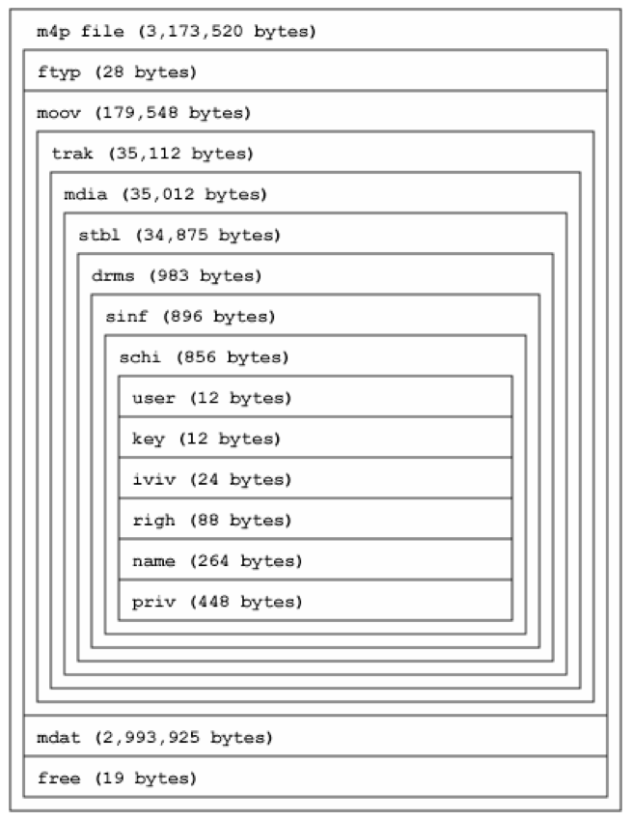
Figure 2: Protected AAC File Structure (Anonymous 2006)
Various atom types are depicted in Figure 2, where, for clarity, some atoms have been omitted. Atoms generally present in a protected file appear in Table 1 (Anonymous 2006). The main difference between the protected file format discussed above and an unprotected file format is that DRM specific atoms such as drms, user, geID, priv, and name, are absent in unprotected files. As mentioned above, unprotected file carry an m4a extension while protected files have an m4p extension.
Table 1: Metadata Information

Atom Name | Atom Data
moov | metadata atom
mdat | encrypted song
drms | container for user, key ,etc.
user | iTunes user ID
key | iTunes user key number
iviv | AES initialization vector
priv | encrypted AES key
name | iTunes user name
geID | watermark information

Atomic Parsley is a lightweight command line tool that can be used to parse the atoms from MPEG-4 files (SourceForge 2006). For our purposes, Atomic Parsley is an invaluable tool for analyzing MPEG-4 files, since it allows us to analyze the differences between protected and unprotected files and to manipulate the metadata atoms in files.

2.2 Fairplay
Fairplay DRM, which is built into the QuickTime multimedia technology, is used to protect digital content purchased from the iTunes online music store. Fairplay has several strong security features. Purchased files are encrypted to provide confidentiality and encryption also plays a role in the persistent protection mechanisms. Also, digital watermarking is used to embed information into the purchased file itself.

Some of the persistent protection restrictions that Fairplay attempts to enforce include the following.

- Protected tracks can only be copied to a specified number of authorized computers.
- A protected track may only be burned into a play list a specified number of times.
- Protected tracks may only be burned into an audio CD a specified number of times.
- Purchased digital content cannot be played on any dedicated digital music devices other than the iPod.
- Fairplay limits the usage of its digital content to the Windows and Macintosh operating systems. Downloaded media is not playable on other major operating systems such as Linux.
- Most audio-editing software used for editing or splicing tracks are not interoperable with iTunes content.

Predictably, these restrictions have angered many users who believe that purchased content should be free to use in any legal manner without undue restrictions (Futureproof 2006). Generally, such critics are opposed to any meaningful DRM, so these criticisms should not be considered as specific criticisms of Fairplay.

Next, we describe the Fairplay DRM system in some detail. The discussion here refers specifically to iTunes version 5, but other versions are similar.

Fairplay DRM has three levels of encryption and each level uses a different key. A system key is a symmetric key that is used by the iTunes server to encrypt user keys and is intended to be unique to a particular system. This key is known to the system and the the iTunes server. The system key is generated on a Windows machine as a hash of items from the registry including bios version, processor name, and Windows version (Anonymous 2006). For Macintosh computers, the system key hash has apparently not been reverse engineered (Anonymous 2006).

A user key database on the iTunes server contains user keys that are needed in the decryption process. Apple uses a few different user keys per iTunes music store account (Anonymous 2006). Among other things, this implies that different media purchased by one user might use the same user key for the decryption process.

The AAC audio data is encrypted with the AES algorithm. This encrypted AAC audio data forms the mdat atom. Furthermore, the AES key used to encrypt the mdat atom is, in turn, encrypted with a user key and this encrypted AES key is stored in the priv atom. The user key is itself encrypted with the system key when it is transferred from server to client.

Next, we consider the scheme used in by iTunes when a user purchases and plays content. It is important to understand this process, since we follow a similar procedure in our proposed P2PTunes system.

2.2.1 Purchasing and Downloading a Song
When a user purchases a song from the iTunes online music store, the following steps occur (Anonymous 2006).

- The user chooses a song from the iTunes online music store and makes a down-load and purchase request to the iTunes server.
- The iTunes client sends the song download request and the user’s system information to the iTunes server.
- The iTunes server sends a download URL and a download key to the iTunes client.
- The iTunes client downloads the file from the download URL and decrypts the file using the download key. This decrypted file contains the protected song, which is then stored on the client computer.
- The client sends a message to the server indicating success of the transaction.
2.2.2 Playing a Purchased Song
The following steps occur when an iTunes client plays a purchased song (Anonymous 2006).
- The user ID and the user key index are extracted from the protected m4p file on the client, and this information is sent to the iTunes server along with the system information.
- The iTunes server uses the user ID and the user key index to retrieve the user key from its key database. The server encrypts the user key using a system key generated from the system information and sends this encrypted key to the client.
- Upon receiving the encrypted user key, the client decrypts it using the system key.
- The client hashes the name and iviv atoms of the specific m4p file to obtain an initialization value.
- The key from step 3 and the initialization value from step 4 are used to decrypt the priv atom which yields the AES key—which is the key that was used to encrypt the content.
- The key from step 5 and the initialization value are used to decrypt the mdat atom, which yields the audio stream that can then be played.

2.2.3 Watermarking
Apple inserts watermarks in protected files as an indicator of legitimate content. Apple’s iTunes software looks for these watermarks to verify the authenticity of the digital content. A tampered file, which does not have a correct watermark is rendered unplayable on iTunes software. However, such content can be played on any AAC compatible hardware or software which does not look for Apple’s watermark, provided the content can be decrypted (Wen 2006). Additional watermarks are cached outside the protected file, specifically, in the iTunes library database and on the iPod. These watermarks are designed to make it a harder to reverse-engineering the system (Wen 2006).

Figure 3 illustrates the interaction between the client (user) and server (iTunes).

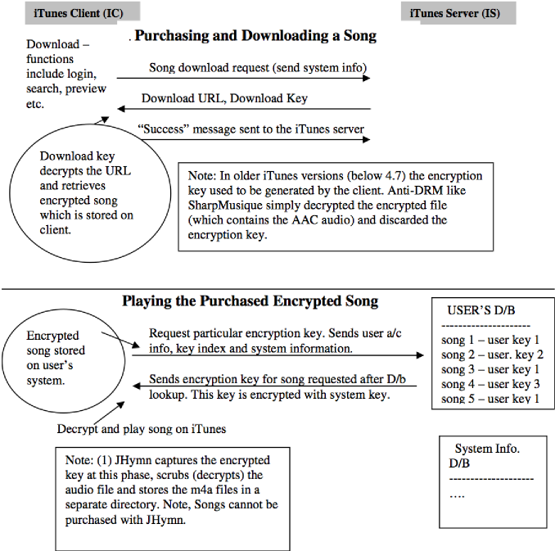
Figure 3: iTunes Protocol for Purchasing and Playing a Song

2.3 Reverse Engineering iTunes
Apple’s Fairplay DRM technology is a closed source system. Reverse engineering a closed source system is generally a difficult task since considerable effort is required to determine specific functionality. Jon Lech Johansen, who cracked the infamous Content Scrambling Scheme (CSS) encryption (used to protect DVD movies), is credited with reverse engineering Fairplay (Indigo Group 2006, Wen 2006). PlayFair, developed by Johansen, was the first successful anti-DRM tool aimed at Fairplay. Other anti-DRM software that exploits Fairplay include PyMusique, SharpMusique, JHymn, and QTFairUse6 (Indigo Group 2006, iPod News 2006).

The iTunes client uses HTTP XML messages to communicate with the iTunes music store and these messages are encrypted using AES in Cipher Block Chaining (CBC) mode. This encryption is for confidentiality, that is, to prevent third parties from eavesdropping (Bornstein 2007, Indigo Group 2006). As with any DRM system, the user must be given all of the “pieces of the puzzle” (specifically, cryptographic keys) to play the digital content.

There are at least three possible ways to exploit Fairplay:

- Interface directly with the music store using a phony client similar to iTunes.
- Get the decryption key from the user’s system since iTunes must give the user any keys needed to play a song.
- Let iTunes software decrypt the content, then write the content to a file in an unprotected form.

The Hymn (Hear Your Music aNywhere) project, based on Johansen’s work, employs a phony client that interfaces with the iTunes online music store (Futureproof 2006, Indigo Group 2006). JHymn, which was authored by someone who uses the alias FutureProof, is a GUI implementation of the original command-line Hymn.

JHymn “scrubs” protected m4p AAC files and produces an unprotected m4a file (Wen 2006). Scrubbing removes Fairplay DRM data from the metadata atoms and leaves unprotected files free of any DRM restrictions. Scrubbed files can be played on any AAC compatible software or hardware and files scrubbed using JHymn are also playable on iTunes since the watermarking information is left intact (Wen 2006).

JHymn can be used on files that have been purchased with any iTunes version prior to iTunes 6.0 (Futureproof 2006). However, if the user performs an activity using iTunes 6.0 or later version, JHymn will not be able to scrub any more files, including files purchased using earlier versions of iTunes (Futureproof 2006).

Version 6 of iTunes remained unbroken until the anti-DRM software QTFairUse6 was released in August 2006. QTFairUse6 captures AAC frames after the song has been decrypted by iTunes, but before the decoding step. The resulting unprotected data is then copied to a file (iPod News 2006). This attack illustrates that no matter how strong the encryption scheme may be, a vulnerability almost certainly remains at the point where the song has been decoded to a format understood by a soundcard. In the case of QTFairUse6, the decoded song is captured by inserting breakpoints in the iTunes client and copying the decrypted song from the computer’s memory into a new file.

2.4 Introduction to P2P Networks
A P2P network consists of a large number of networked computers or nodes, often connected in an ad-hoc fashion (Daswani, Garcia-Mollia, and Yang 2002, Peer-to-peer 2006). Each peer can function as a server (content provider) or a client (consumer), or both simultaneously (Han, et. al., 2004; Mannak, Ridder, and Keyson, 2004).

P2P systems make file sharing more efficient since the primary costs of sharing data, namely, bandwidth and storage are distributed across the peers of the network. This ensures scalability and eliminates the need for powerful and expensive servers (Daswani, et. al., 2002).

P2P architectures can be classified as either centralized or decentralized (Han, Liu, Xiao, et. al., 2004). Many real-world P2P systems combining features of both centralized and decentralized architectures.

One of the best-known centralized P2P system is Napster (France, Moore, and Dreier 2007) which uses a central server to index the content stored on peers. Kazaa could also be considered a centralized P2P system, although it is more decentralized than Napster, since the function of the centralized server is distributed among a number of peers.

In general, centralized P2P systems rely on centralized servers for specific tasks such as bootstrapping, obtaining keys for data encryption, adding new nodes to the network, and so on. The nodes in centralized systems may be involved in such tasks as locating and caching content, searching for other nodes, routing messages, encryption, decryption, and verifying content (Androutsellis-Theotokis 2004). Centralized P2P systems are vulnerable to denial of service attacks (Han, Liu, Xiao, et. al., 2004) or legal assaults aimed at shutting down the centralized server.

P2P networks that share computer resources without requiring intermediation from a centralized server are known as decentralized systems. Gnutella is an example of a decentralized P2P system. Decentralized P2P systems enjoy high fault-tolerance, good scalability, the ability to self organize (in spite of highly transient node populations), and access to resources (Androutsellis-Theotokis 2004).

There are several technical challenges that inhibit the widespread acceptance of P2P systems for legitimate content distribution. Such challenges include security, performance guarantees (e.g., atomicity and transactional semantics), and unreliable peers (Daswani, et. al., 2002).

Some of the potential security pitfalls of sharing information over a P2P network include the installation of malicious software, attacks based on the ports opened to transmit files, and denial of service attacks. Client nodes can defend themselves against some of these attacks by using antivirus software and enabling firewalls (United States Computer Emergency Readiness Team 2006).

Several techniques can be employed to address certain security issues at the P2P system level. Cryptographic techniques such as integrity checks and information dispersal algorithms or Shamir’s secret sharing scheme are sometimes employed to prevent specific types of attacks. For example, nodes may be required to compute cryptographic hashes to verify the integrity of retrieved data, thereby preventing certain types of spoofing attacks (Androutsellis-Theotokis 2004). Information dispersal algorithms or Shamir’s secret sharing scheme can be used to distribute files, in which case complete information cannot be obtained by any intermediate nodes in the P2P network.

“Free riding” is another common problem in P2P networks. That is, some nodes refuse to service requests for content that they are capable of providing. Nodes may misrepresent information such as available bandwidth so that they receive fewer requests and thereby save their own resources, to the detriment of the network as a whole (Saroiu, Gummadi, and Gribble 2002). This can result in fewer server nodes and more client nodes and an overall loss of efficiency in the P2P network. Several techniques are available for reducing the effect of free riding in P2P networks.

2.5 Goals of this Research
Our goal is to create a reasonably secure DRM scheme for a P2P network. Since security in DRM systems is difficult—if not impossible—to quantify, we have chosen to model our system after one of the most successful and practical DRM schemes yet developed, namely, iTunes. Our system, P2PTunes, can be viewed as a modified form of iTunes that can easily function over any typical P2P network. P2PTunes is designed to provide the following security and performance features.

- The overall level of security is equivalent to Fairplay DRM.
- The file sharing and bandwidth-related advantages of the underlying P2P net-work are not impaired.
- The confidentiality of transactions is assured.
- The integrity of digital content transferred over the underlying P2P network is verified.
- High assurance of authenticity for purchased digital content is provided.

2.6 Previous Work
In this section, we briefly review previous attempts to combine DRM and P2P networks. Perhaps the most ambitious such system to date is Music2Share (Kalker, et. al., 2004). Music2Share is a proposed P2P protocol with built-in DRM that manages legitimate music tracks using a variety of advanced technologies, with a heavy reliance on watermarking. However, many of the crucial “technologies” employed in Music2Share rely on successful resolution of difficult unsolved research problem. The authors of Music2 Share admit that the application of many of these technologies “has to be worked out and refined” (Kalker, et. al., 2004).

Our design goal for P2PTunes is, in a sense, diametrically opposed to that of Music2Share. For P2PTunes, we insist that the system can be built using technology that exists today and we want our system to be P2P-agnostic, that is, we want P2PTunes to function seamlessly within any typical P2P system. We have modeled P2PTunes on a highly successful DRM system, which provides some degree of confidence that our system would actually be viable in the real world.

Napster, a centralized P2P file sharing system, was infamous for facilitating illegal music downloads. Napster has morphed into a legal music download service, which uses Windows Media DRM. Downloads are encoded as high-quality 192Kbps Windows Media Audio (WMA) files. Napster allows registered users to stream tracks a certain number of times from its catalog to Windows, Macintosh, and Linux machines. Streamed tracks, which are encoded with a low bit rate, cannot be stored on the user’s system. A Napster client is required for song purchases and downloads. Napster’s online streaming works well on Windows although there appear to be some performance issues on Macintosh. Napster’s client software hangs at times, not al-lowing users to adjust the volume, pause, or skip ahead. Napster does provide an innovative feature that allows users to explore other member’s collections by genre; however, this feature is apparently somewhat buggy (Chandak 2005, France, Viksnins, and Kim 2007).

Rhapsody 3.0, which is owned by Real Networks, offers an on-demand streaming service and download access from its music catalog (France 2007). Purchased tracks are 192Kbps AAC files wrapped in Real Network’s Helix DRM. Rhapsody allows users to listen to a certain number of tracks for free each month; these tracks are encoded at 128Kbps, which results in lower quality music as compared to purchased tracks. Rhapsody 3.0 works on Windows XP, Me, 2000, or 98SE platforms, but users have reported difficulty logging onto the service, which may be attributed to high server traffic volume (Chandak 2005, France, Viksnins, and Kim 2007). Other examples of P2P-based download services include eMusic, Yahoo Music Unlimited 1.1, Sony, etc. The eMusic scheme is noteworthy since it offers a catalog of songs from independent labels and these songs are provided in the unprotected mp3 format. There is a maximum download limit per month after which songs may be purchased (Chandak 2005, France, Viksnins, and Kim 2007).

Design of P2PTunes
Our proposed DRM system, P2PTunes, adapts the existing iTunes Fairplay DRM so that is applicable over an existing P2P network. In this section we first discuss the design and architecture of P2PTunes in general terms, then we fill in the details.

3.1 A Hybrid Approach
The strength of P2PTunes lies in obtaining the benefits of the underlying P2P system while ensuring the security aspects that are required of a viable DRM system are provided. In addition, the design of P2PTunes ensures that it functions over any typical P2P system.

P2PTunes allows users to purchase encrypted digital media such as audio and video content over the P2P network. Within the P2P network, each peer can function as both a content provider (server) and a consumer (client). Client nodes broadcast queries for specific digital content while server nodes service these requests. A node acts as a server if it has the requested content and is willing to share it. Nodes acting as client nodes in one transaction, could act as server nodes in another transaction.

In P2PTunes transactions, digital content is always transmitted in encrypted form over the P2P network. This prevents intermediate nodes and client nodes from “grabbing” the content before a payment is made. P2PTunes itself is as decentralized as the underlying P2P network, with the exception of certain transactions such as payments, billing, and content authenticity verification. These operations are performed at a centralized server to ensure the legitimacy of P2PTunes transactions. However, these centralized operations are designed so that they put only a small burden on the centralized server. The actual content is distributed entirely within the underlying P2P network.

A secure connection between the client node and centralized server is used for payment processing. In addition, the centralized server validates the authenticity of the purchased digital content. The introduction of the centralized server, in combination with a decentralized P2P network, makes P2PTunes a hybrid model. This hybrid model enables us to achieve an efficient and secure distribution system for sharing legal digital content. The resulting system provides security equivalent to iTunes together with the efficient distribution inherent in the underlying P2P network.

3.2 Entities in P2PTunes
The main entities in P2PTunes are the following.

- The originator O is a client node that initiates a request for digital content over the P2PTunes network.
- The responder R is a server node that is able and willing to service the originator’s request.
- An intermediary node P is a node that forwards O’s request or R’s response. Such an intermediate node may or may not be a participant in the underlying P2P network.
- The P2PTunes Server (PTS) is a centralized server that handles financial and authenticity issues. Note that the PTS is a trusted component of P2PTunes.

3.3 Architecture of P2PTunes
This section describes the architecture of P2PTunes in some detail. The emphasis is on the interaction between the various entities of P2PTunes and how digital content is securely distributed over the P2PTunes network.

3.3.1 P2PTunes Metadata
Every protected m4p file contains priv and iviv atoms enclosed within the moov atom. The priv and iviv atoms are pivotal to the decryption process. Other atoms such as user, key, and name contain user specific information: the iTunes user ID, the user key index, and the user name, respectively. Figure 4 depicts these security-critical atoms. For a more detailed view of atoms, refer to Figure 2.

In P2PTunes, different digital content may be encrypted with the same AES symmetric key. The AES key is used to encrypt and decrypt the mdat atom. The AES key is itself encrypted with a user key (which is user-specific so that it differs from user to user) and stored in the priv atom. The user key is, in turn, encrypted with a system key when it is transmitted from the server to the client. The system key is both user and system specific. The P2PTunes Server (PTS) uses system information from the user’s system to generate the system key. The PTS stores different user keys per account and employs a user key index (found in the m4p file) to retrieve a user key from its user database. Hence, user-specific atoms play a role in retrieving the user key from the server’s database. Note that this use of keys is completely analogous to the approach used in iTunes, as discussed in Section 2.2 above.

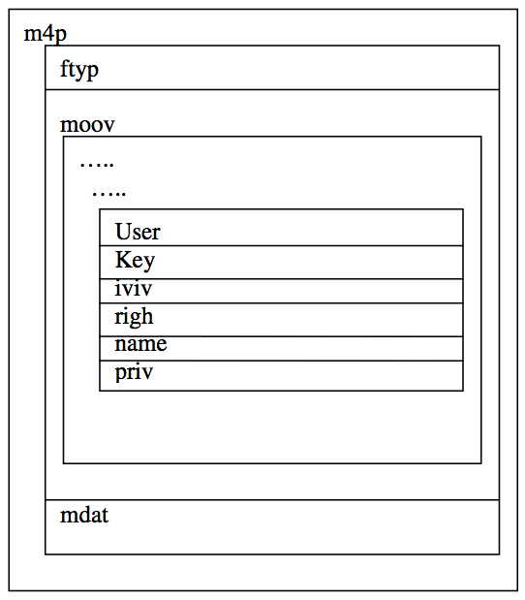
Figure 4: Key Atoms in an m4p File

3.3.2 Purchasing and Playing a Song
Figure 5 illustrates a network consisting of an originator O, intermediary nodes Pi and responder nodes Rj in a simple P2P network.
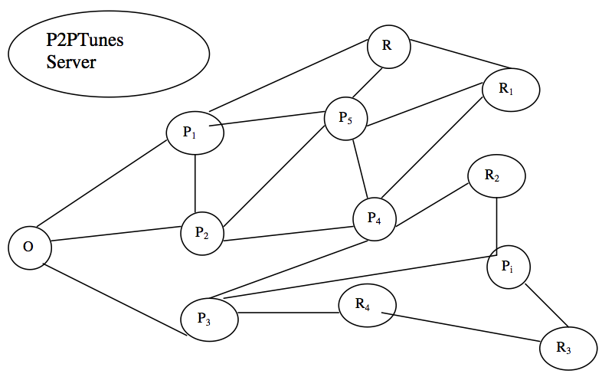
Figure 5: A Sample P2PTunes Network

The steps involved in purchasing digital content over P2PTunes are the following:

Step 1: Initiate Request — The originator O (client node) initiates a request for specific digital content, say, a song S. The request S along with O’s identifier is transmitted over the underlying P2P network. The identifier ties the request to the node O.

Step 2: Respond to Query — A responder R (server node) possesses the requested digital content and is willing to share it. Upon receiving the request for S, node R sends its identifier and song information (which include title, song number, version number, etc.) to O. The identifier ties the response to R. Note that there could be more than one responder to a query.

Step 3: Select Response — Node O receives responses from n responder nodes, say, R1, R2, . . . , Rn. Then O chooses one responder, say, Ri. Depending on the underlying P2P network, choosing a responder may be based on factors such as specific digital content information (title, version number, artist, etc.), the speed of the connection between client and server, or the responder node may be known and trusted by the originator.

Step 4: Inform Responder — Node O requests the chosen Ri to deliver the song S by sending a download or “request-confirm” message to Ri.

Step 5: Transmit Encrypted Content — Upon receiving O’s message, Ri encrypts its account information and a timestamp with the PTS public key. Note that the PTS employs a secure public key cryptosystem such as RSA to generate a public and private key pair. Node Ri computes the hash of the encrypted song and the encrypted account information. Node Ri strips the user-specific atoms such as those containing the name, user ID, etc., from the m4p file and sends the content byte stream to O. This byte stream contains of the following information.
- The encrypted song (excluding the user-specific atoms).
- The node Ri’s encrypted account information and timestamp.
- A CRC checksum of the encrypted song and the encrypted account information.
The purpose of encrypting Ri’s account information with the current timestamp is to prevent misuse by O. Since this information is encrypted with the PTS public key, O will not be able to decrypt this message. Additionally, the timestamp allows the PTS to ensure that the transaction is current. Intermediate nodes can cache this content and later forward it over the P2P network. This process would allow for more efficient use of network bandwidth.

Step 6: Verify Integrity at O — Node O receives Ri’s encrypted message. Node O verifies the integrity of the song by computing the CRC checksum of the encrypted content and verifying it against that received from Ri. Once verified, O has the encrypted song received from Ri. Note that this check is designed to detect errors in transmission. However, this check does not ensure that the received content is actually the content requested by O, since Ri could have substituted an incorrect file for the requested file (either intentionally or accidentally).

Step 7: Verify Authenticity — It is necessary for O to verify the authenticity of the m4p file it received from Ri. To accomplish this, node O computes a hash of the non-user specific atoms in the received file. User specific atoms that vary from user to user such as priv, user, name, etc., are not present in the byte stream and hence are not part of the hash computation. Note that the atom mdat (which contains the encrypted song) is encrypted with the same AES key for every user, which implies that mdat is not user-specific. Therefore, we can (and do) include mdat in the authenticity hash computation. The computed hash value and the unique song number are sent to the PTS for verification. To verify the authenticity, the PTS simply compares the received hash value with the computed hash value of the content, which it has stored in its database. This enables the PTS to verify whether the hash value received from O matches that of the content. Note that only the hash value is sent to the PTS, not the data itself and no hash computation is required on the PTS server, since the hash has been pre-computed and stored in the PTS database. In this way, the PTS verifies the authenticity of the content with minimal overhead imposed on the PTS or the network. If the song is not authentic, the PTS informs O, and O can try another source.

Step 8: Payment Processing — To be able to play the song, O must be able to decrypt the song. The decryption key is provided to O only after O makes a payment to the PTS. To make a payment, O connects to the PTS though a secure connection, based on the system key. Then O sends the following information to the PTS.
- Node O’s account information.
- The song information (including the unique song ID number).
- Node Ri’s encrypted user information.
Note that this is essentially the same process used in iTunes, as outlined in Section 2.2.1, except that in P2PTunes, the responder’s information is also included.

Step 9: Insert User-Specific Atoms — Upon completion of the payment step, the PTS generates all of O’s user specific atoms. Node O sends its system information to the PTS, which uses this information to generate a system key. Node O’s user-specific atoms are encrypted with the system key by the PTS. Note that as in iTunes, the system key is stored on the client (i.e., the originator O’s system). The PTS sends the required priv atom for the content downloaded in Step 5 to O. In addition, the PTS generates and sends O’s user-specific atoms pertaining to information such as the user key index and the name atoms to O. The iTunes software functionality is enhanced so that P2PTunes can add these user-specific atoms received from the PTS to the m4p file downloaded in Step 5. This step is critical since whenever O plays the song, the PTS looks up information from these atoms to retrieve the user key.

Step 10: Play Purchased Content — Each time the node O wants to play a track, it provides the song ID, user specific information (from the m4p atoms), and its system information to the PTS. The PTS uses the song and account information sent by O as an index into its database and retrieve the appropriate user key. The user key is then encrypted with the system key generated by the PTS and sent to O. The following three levels of decryption are required to access the audio data.
1. Node O uses the system key (stored on the client) to decrypt the encrypted user key received from PTS. The decrypted user key is used to decrypt the priv atom. This retrieves the AES private key.
- The AES private key obtained in step 2 and the initialization vector (obtained by hashing the name and iviv atoms) are used to decrypt the audio data found in the mdat atom.
Note that this is similar to the way digital content is decrypted and played in iTunes. The architecture described in this section is illustrated in Figure 6.
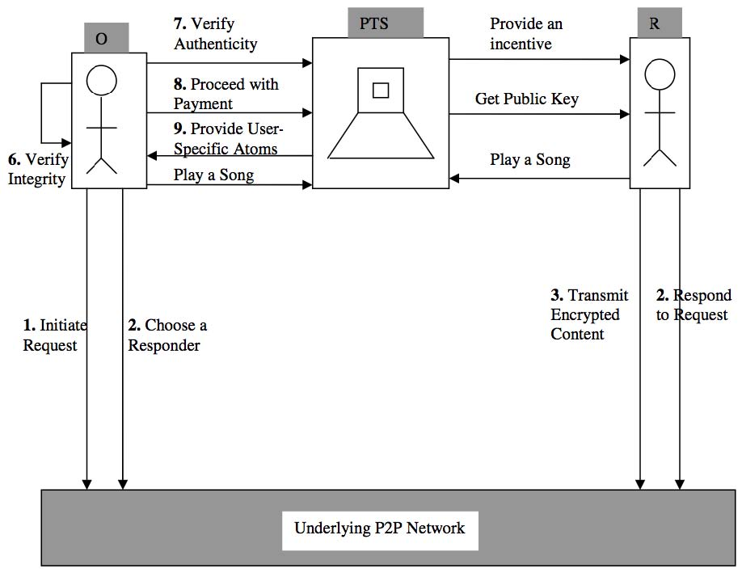
Figure 6: P2PTunes Functional Architecture

3.4 Advantages of P2PTunes
This section summarizes the advantages of our proposed P2PTunes system. Each of the following is an advantage of P2PTunes, as compared to iTunes.

- In iTunes, digital content purchases are made at a centralized server that services each request by providing the digital content. This consumes a great deal of bandwidth and creates a potential bottleneck. In contrast, in P2PTunes the bandwidth requirement at the central PTS server is minimal since the actual content is shared over the underlying P2P network.
- The P2PTunes design has all of the advantages of a P2P community with active user participation and community networking (Mannak, Ridder, and Keyson 2004).
- In P2PTunes, each m4p files has user-specific metadata tags pertaining to a specific user, which is identical to the iTunes system. Consequently, from a user’s perspective, playing purchased content in P2PTunes is identical to iTunes. Note that in both systems, users need permission from the centralized server to play content.
- In general, P2PTunes offers a similar user experience to iTunes. The only significant difference is that in P2PTunes, a user selects the server peer from which to download the content, while in iTunes the user always obtains the content directly from the central iTunes server.
- In P2PTunes, confidentiality of the responder is protected to some degree since the responder node removes its user-specific atoms from the protected file before sending it over the P2P network.

3.5 P2P Issues
As discussed above, nodes in P2P networks may misrepresent information such as bandwidth in order to service fewer requests, or no requests at all (Saroiu, Gummadi, and Gribble 2002). This “free riding” could create an environment with a large number of client nodes and fewer server nodes which would negates some of the advantage of a P2P architecture. Taken to the extreme, this effect cause P2PTunes to degenerate into essentially the equivalent of iTunes with a centralized server (or a few such servers) distributing the content. By offering a small financial incentive to those who distribute content that results in a purchase, P2PTunes could reduce the effect of free riding.

Another issue is that participants in P2PTunes may simply share unencrypted content over the underlying P2P network. However, the equivalent of this scenario occurs with iTunes today. As discussed above, there are many tools for scrubbing content purchased via iTunes, and there is nothing to prevent these scrubbed files from being uploaded to P2P networks. Again, in P2PTunes, we can encourage users to share encrypted content by rewarding distributors with a small financial reward from the PTS. This would create an incentive for users to “play by the rules”.

Implementation and Testing
The implementation of our P2PTunes prototype is discussed in detail in (Venkataramu 2007). Here, we simply point out that such a prototype has been created and that the prototype includes the full P2PTunes functionality described above. In addition, thorough testing has been conducted to validate the functionality and security of the design. See (Venkataramu 2007) for complete details on the implementation and testing of our prototype P2PTunes application.

Security
In this section we consider some security issues that arise in P2PTunes. The goal here is to illustrate that P2PTunes is as secure as iTunes. We now consider the basic steps that occur when content is purchased and played in P2PTunes. For each step, we discuss relevant security issues.

Initiate Request
An originator node O broadcasts a request for content over the P2PTunes network. At this stage intermediate and responder nodes are aware of the identity of the originator node. That is, anonymity is not provided by P2PTunes. An alternative would be to use a secret-sharing-based mutual anonymity protocol to allow peers to issue queries and responders to deliver responses anonymously (Han, Liu, Xiao, et. al., 2004). However, we do not believe this overhead is warranted, given that legitimate content is being distributed and participants need to be identified if financial incentives are to be a part of the system.

Respond to a Request
Responder nodes send file index information containing details of the content and the identity of the responder node to the originator. The size of the file index sent is on the order of a few kilobytes which is much smaller than that of the actual audio data. Consequently, this step uses little of the P2P bandwidth. The potential security issue at this stage is that malicious nodes could bombard an originator with a large number of dummy index files which might result in the originator node’s system hanging. In general, there are no easy preventative measures for this type of distributed denial of service attack.

Choose Specific Content
The originator node chooses a particular piece of content, based on details indicated in the responses. A download request is sent to the corresponding responder node over P2PTunes. At this stage, the originator can make an informed choice based on the content information and the responder’s ID. We could enhance this process by employing a rating system where responders are rated by other users and by the PTS.

Content Transmitted
At this stage, the requested content is transmitted from the responder to the originator over the P2P network. The content file (a protected m4p file) consists of atoms, each of which contains information pertaining to the content (e.g., artist name), identification information (e.g., iTunes user ID), the encrypted song, and cryptographic information (e.g., encrypted keys).

The responder strips the user-specific atoms from the m4p file and prepares a byte stream. The absence of the identification atoms prevents intermediate nodes from identifying the responder and hence provides a degree of anonymity. In addition, atoms essential to the decryption process, namely the priv atom (which contains the encrypted AES key), the name atom (identification atom), and so on, are not transmitted, thereby discouraging intermediate nodes from trying to decrypt the mdat atom and recover the song in an unprotected form. Additionally, since user-specific atoms are not present in the byte stream, intermediate nodes cannot easily act as a fake responder node and request user keys from the PTS. If a node adds its user-specific atoms to the protected file and requests the user key from the PTS, the PTS would not comply since it could easily verify from its database that the particular node has not purchased the song. Hence, these security measures thwart certain attacks by unscrupulous intermediate nodes.

Note that any intermediate nodes involved in the routing are aware of the content details since the atoms of the transmitted m4p file include the artist name, the purchase date, the album name, copyright information, and the mdat atom (which contains the encrypted song). Nodes cannot decrypt the responder node’s account information (consisting of its user name and user ID) from the byte stream since it is encrypted with the PTS public key. Hence, neither the intermediary nodes nor the originator node can view or alter the responder’s account information.

The responder computes a CRC checksum of the byte stream, which the originator node uses to verify error-free transmission of the content. The intermediate nodes can cache the content involved in the transaction and later forward the same digital content in response to similar requests originating from different nodes. This will make more efficient use of the P2P bandwidth (Fairplay 2006).

As in P2PTunes, content cannot be played from unauthorized machines since the PTS requests system information from nodes. This system information must match that in the PTS database before the PTS will verify legitimate ownership and provide decryption keys (Apple 2006).

Originator Receives Data
The originator verifies the integrity of the content against the received checksum to be certain that the data has not been corrupted. Subsequently, the originator verifies the content authenticity with the PTS (by computing a cryptographic hash) to ensure that an unscrupulous node did not tamper with the content. The integrity and authenticity computations take place at the participating P2PTunes nodes. This leaves the centralized PTS system with few computational tasks and makes efficient use of the P2P bandwidth.

Role of PTS
The role of the PTS is to verify the authenticity of the song and to send appropriate error messages allowing the originator to choose a different source in case of a failure. Furthermore, the PTS is responsible for billing and generating user-specific atoms to be added to the purchased m4p file by the originator’s software. Once the originator receives the user-specific atoms, it can request the user keys from the PTS to play any purchased content.

Authenticity verification occurs between the originator and the PTS. The originator calculates the hash value of non-user specific atoms in the digital content using a cryptographic hash. The calculated hash value, along with the content ID and encrypted account information is sent to the PTS, which validates the received hash value for the specified content. In addition, the PTS verifies whether the responder has purchased the song by decrypting the responder’s account information and confirming ownership against its database. This guarantees that the digital content is from an authentic source.

The user-specific atoms generated by the PTS are small compared to the m4p content file. The PTS generates a priv atom, which contains the encrypted AES key. Additionally, the name atom (consisting of the user name) and the user atom (consisting of the user ID) are generated and sent to the originator O through a secure connection that O establishes with the PTS (based on O’s system key). Then O’s P2PTunes client software inserts these atoms into the MPEG-4 file, thus forming a complete protected file.

Playing Purchased Content
This step is identical to the corresponding step in iTunes, as outlined in Section 2.2.2.

Conclusion
The P2PTunes design is geared to efficiently utilize P2P bandwidth for content transactions and effectively delegate as much of the computational task as possible to client nodes. The role of the centralized PTS server is reduced to validating data, per-forming inexpensive computations, and handling financial transactions. This design significantly reduces the load on the PTS server since the amount of data involved in transactions between client nodes and the PTS is small in comparison to the iTunes model.

In addition, P2PTunes provides a venue for users with similar interests to inter-act and share content, fostering social networking. Rewarding participating nodes with royalty payments or other incentives could generate additional user interest and possibly reduce attacks while increasing community participation in the P2PTunes network.

In the iTunes design, the centralized server handles multiple functions and its bandwidth is occasionally under strain. For instance, swarms of online shoppers armed with iTunes gift cards overwhelmed the iTunes music store, prompting error messages and slowdowns in downloads (Montgomery Advertiser 2007). Additionally, digital distribution of video requires far more bandwidth than music and hence increases the load on the server. This potential bandwidth bottleneck is avoided in our P2PTunes system, where users of the underlying P2P network share music over the P2P network instead of approaching the centralized system.

There are many security challenges related to sharing digital content over a P2P network. Our P2PTunes design demonstrates that it is feasible to extend iTunes to a P2P system while employing sufficient security measures to make the resulting system at least as secure as iTunes.

Of course, P2PTunes is not immune to all security attacks. Reverse engineering tools like JHymn can be used to scrub protected files in iTunes as well as P2PTunes. Users could therefore make use of JHymn-like tools and share the resulting unprotected files. Installation of watermarking features such as the ge ID atom (present in m4p file) do little to deter such attacks since reverse engineering tools such as JHymn take care not to strip information that iTunes requires to play the content. This makes it a difficult task for the iTunes client to detect whether the content is in a protected or unprotected format. This same attack scenario applies to P2PTunes.

Care has been taken to make P2PTunes suitable for deployment over a P2P net-work, while having security comparable to iTunes. The P2PTunes DRM system is strong enough to withstand selected attacks but cannot be deemed totally secure, as is the case for all software-based DRM systems available today.

Future Work
The P2PTunes DRM system can incorporate numerous additional security measures and additional useful features. Some of these useful features and security measures are briefly considered in this section.

The anti-Fairplay tool QTFairUse6 captures the AAC frames after the song has been decrypted by iTunes version 6.0, but prior the decoding step, and copies the unprotected date to a file (iPod News 2006). This attack illustrates that a major vulnerability exists at the point where the data is converted to a format understood by a sound card. A trusted operating system (OS) could prevent such an attack by verifying that software running on the system is not malicious. Therefore, one way to greatly improve the security of P2PTunes—or any DRM scheme—is to implement the system within a trusted OS environment. For example, P2PTunes together with Microsoft’s Next Generation Secure Computing Base (NGSCB) could provide vastly improved DRM security (Microsoft 2006).

Many additional features could be implemented to enhance P2PTunes. For example, the following features may be worth considering.

- Client nodes of P2PTunes can invite other users in their “friends” list to buy digital content from each other. A user knows her friends’ music or content preferences and can suggest appropriate purchases. This might increase sales by taking advantage or social networking.
- Features could be built into P2PTunes to allow users to rate digital content and post to message boards. This would inform users of digital content available for purchase and further strengthen the social networking aspects of the system.
- In our implementation of P2PTunes, the PTS server is able to identify whether responder nodes have sent invalid content in response to an originator’s request. This could be used by the PTS to blacklist misbehaving responder nodes. Then originators could avoid purchasing content from blacklisted responder nodes.

References

Androutsellis-Theotokis, Spinellis. (2004). A survey of peer-to-peer content distribution technologies, ACM Computing Surveys, Vol. 36, pp. 335–371

Anonymous. (2006). Hymn Manual, Retrieved on August 30, 2006 at http://hymn-project.org/documentation.php

Apple Computers, Inc. (2006). MPEG-4: The container for digital media, Retrieved on August 21, 2006 at http://www.apple.com/quicktime/technologies/mpeg4/

Bailes and Templeton. (2004). Managing P2P security, Communications of the ACM, Vol. 47, pp. 95–98

Bornstein, N. (2007). Hacking iTunes, Retrieved on April 5,2007 at http://www.xml.com/pub/a/2004/11/03/itunes.html

Chandak, G. (2005). Can iTunes be weTunes? — Is FairPlay playing fair? 20th BILETA Annual Conference, 2005

Daswani, Garcia-Mollia, and Yang. (2002). Open problems in data-sharing peer-to-peer systems, Proceedings of the 9th International Conference on Database Theory, Vol. 2572, pp. 1–15

France, Moore, and Dreier. (2007). Napster, Retrieved on April 7, 2007 at http://reviews.cnet.com/Napster/4505-3669_7-31302303.html

France, J. (2007). Rhapsody 3.0, Retrieved on April 7, 2007 at http://reviews.cnet.com/Rhapsody_3_0/4505-9239_7-20050753.html?tag=also

France, Viksnins, and Kim. (2007). eMusic, Retrieved on April 7, 2007 at http://reviews.cnet.com/eMusic/4505-9240_7-30974740.html?tag=also

Futureproof. (2006). JHymn project, Retrieved on August 24, 2006 at http://hymn-project.org/jhymndoc/

Han, et. al. (2004). A mutual anonymous peer-to-peer protocol design, Proceedings of the 19th IEEE International Parallel and Distributed Processing Symposium, p. 68

Indigo Group. (2006). Fairplay: effectiveness and weaknesses of Apple’s digital rights management technology, Retrieved on August 20, 2006 at http://www.simson.net/ref/2005/csci_e-170/p1/indigo.pdf#search=%22indigo%20fairplay%22

iPod News. (2006). QTFairUse6 circumvents iTunes DRM, Retrieved on August 30, 2006 at http://www.ipodnn.com/articles/06/08/30/itunes.drm. circumvented/

Kalker, et. al. (2004). Music2Share: Copyright-compliant music sharing in P2P systems, Proceedings of IEEE, Vol. 92, pp. 961–970

Mannak, Ridder, and Keyson. (2004). The human side of sharing in peer-to-peer net-works, ACM International Conference Proceeding Series, Vol. 84, pp. 59–64

Microsoft. (2006). Next generation secure computing base, Retrieved on March 17, 2006 at http://www.microsoft.com/resources/ngscb/default.mspx

Microsoft. (2007). Peer-to-peer file sharing: Help avoid breaking copyright laws and getting unwanted software, Retrieved on April 3, 2007 at http://www.microsoft.com/athome/security/online/p2p_file_sharing.mspx

Montgomery Advertiser. (2007). iTunes slowdown, Retrieved on January 3, 2007 at http://www.montgomeryadvertiser.com/apps/pbcs.dll/frontpage

Rodrigues, Liskov, and Shrira. (2002). Peer-to-peer: The design of a robust P2P system, Proceedings of the 10th ACM SIGOPS European Workshop: Beyond the PC, pp. 117–124

SourceForge. (2006). AtomicParsley, Retrieved on September 16, 2006 at http://atomicparsley.sourceforge.net/

Saroiu, Gummadi, and Gribble. (2002). A measurement study of peer-to-peer file sharing systems, Multimedia Computing and Networking, Vol. 153, pp. 156–170

Stamp, M. (2003). Digital rights management: For better or for worse?, Extreme Tech, May 20, 2003, Retrieved July 3, 2007 at http://www.extremetech.com/article2/0,3973,1051610,00.asp

Stamp, M. (2006). Information Security: Principles and Practice, Wiley-Interscience, 2006

Sun Developer Network. (2007). Remote method invocation, Retrieved on March 12, 2007 at http://java.sun.com/javase/technologies/core/basic/rmi/index.jsp

Tanin, Nayar, and Samet. (2005). An efficient nearest neighbor algorithm for P2P settings, Proceedings of the 2005 National Conference on Digital Government Re-search, Vol. 89, pp. 21–28

United States Computer Emergency Readiness Team. (2006). Risks of file-sharing technology, Retrieved on November 3, 2006 at http://www.us-cert.gov/cas/tips/ST05-007.html

Venkataramu, R. (2007). Analysis and enhancement of Apple’s Fairplay digital rights management, Master’s report, Department of Computer Science, San Jose State University, 2007, Retrieved July 3, 2007 at http://www.cs.sjsu.edu/faculty/stamp/students/RamyaVenkataramu_CS298Report.pdf

Wen, H. (2006). JHymn goes behind atoms and Apple to bring DRM-free music, Retrieved on September 14, 2006 at http://osdir.com/Article3823.phtml

Fairplay (2006), Wikipedia, Retrieved on August 21, 2006 at http://en.wikipedia.org/wiki/FairPlay

Peer-to-peer (2006), Wikipedia, Retrieved on October 7, 2006 at http://en.wikipedia.org/wiki/Peer-to-peer

Key Terms

Digital Rights Management (DRM) consists of the methods used to control access to copyrighted digital content.

DRM (see Digital Rights Management)

Peer-to-peer networks (P2P). A P2P network consists of a number of networked computers, often connected in an ad-hoc fashion. Each peer can function as a server (content provider) or a client (content consumer), or both simultaneously. P2P architectures can be classified as either centralized or decentralized.

P2P (see peer-to-peer networks)

iTunes is a proprietary software application which is used to connect to the iTunes online store to download digital content. The iTunes software is used to manage play lists among computers and iPods, and to play digital content on Windows computers, Macintosh computers, and the iPod.

Fairplay is a digital right management (DRM) technology used to protect digital content purchased from the iTunes online store. As with most DRM systems, the purpose of Fairplay is to place restrictions on the uses of copyrighted content.

P2PTunes is designed to provide the benefits of a decentralized P2P network while providing DRM content protection that is at least as strong as that found in Fairplay. P2PTunes can operate over any existing P2P network.

