Virtual Private Networks

What is a Virtual Private Network (VPN)?
A Virtual Private Network is an extension of a private network that encompasses links across shared or public networks like the Internet – Virtual Private Networking in Windows 2000: An Overview by Microsoft

An encrypted or encapsulated communication process that transfers data from one point to another point securely; the security of that data is assured by robust encryption technology, and the data that flows passes through an open, unsecured, routed network. –Brown Steven, Implementing Virtual Private Networks.

A VPN is a data network that makes the use of the public network infrastructure, maintaining privacy through the use of a tunneling protocol and security procedures. One of the key technologies used to promote the security procedures in VPN is encryption. One can argue that VPN is almost undoable without encrypting data along the path. It is so convinced that the Oreilly authors Scott et. al. state that a VPN is possible without using firewall, but not without using encryption technology. Hence, it assures that cryptography plays a huge role in maintaining the security of flow of data in VPN technology.

One way of looking at VPN is that it is a simple process of sending encrypted data from one point to another, usually over the Internet. However, VPN can also be used on leased lines, frame relay/ATM links, or Plain Old Telephone Network (POTN) services, such as Integrated Service Digital Network (ISDN) and Digital Subscribe Line (xDSL). Some ISPs already provide some VPN implementations, such as in frame relay topologies. While it is a private network from an ISP's point of view, it is still a public network from a customer's point of view. By adding VPN technology to their frame segment, customers can get the additional benefits of VPN technology (Brown, 6).

Types of VPN
As VPN technology has gained its popularity among the corporate networks, nationally or internationally, within the past few years, it has emerged in many flavors to provide services to the needs of those customers. Four areas of VPN described below are to clarify the differences between different types of VPN in existence and figure 1.1 below provides a pictorial view of its use.

Intranet An intranet VPN is created between the corporate headquarters and a remote sales office, or between headquarters and remote satellite offices.
Remote Access A remote access VPN is created between corporate headquarters and remote mobile users.
Extranet An extranet VPN is created between a corporation and its customers or suppliers.
Intracompany A fourth area, not readily deployed by companies today, is an internal intracompany VPN. It is created within the corporate network to prevent critical data by encrypting and safely storing it without being tampered with. What reasons would cause a company to use an intracompany VPN? Some of the reasons are set forth by security surveys that report that attacks by internal employees are their number-one threat.

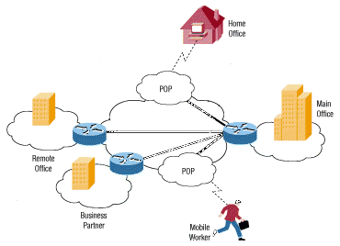

Figure 1.1

However, four types of VPN, as mentioned below, are used in the aforementioned areas to meet the customer’s needs.
Trusted VPN - A VPN type used in an environment where the customers trust the technology to maintain the integrity of the circuit and use the best available security to avoid network traffic sniffing.
Secure VPN - All data transferred in this VPN is encrypted and authenticated so that no one from outside can affect its security properties.
Hybrid VPN - In this VPN, a secure VPN is run as part of a trusted VPN.
Provider-Provisioned VPN - VPN where the trusted VPN and trusted part of the hybrid VPN are usually administered by the ISP or some authority other than the user.

Security Risks of the VPN
VPN is a technology based on a platform-independent public network infrastructure such as the Internet. It uses the public network to transmit data across to the allocated users, presumably, safe in transit. However, the integrity and safety of data in transit over the Internet is never guaranteed because of its openly used public network infrastructure. Data over the Internet is uncontrollably vulnerable and the technologies used to promote security issues are noticeably untrustworthy. Quite often we hear, someone stealing someone else’s credit card number, prying into others private documents or gaining access to restricted machines over the Internet; these scenarios are only few of the examples to verify the vulnerability of data in transit over the Web. And there are many other known and unknown loopholes in this technology that we may not even be aware of.

Some of the challenges that VPN has to meet in order to provide a high-level security are to protect against basic firewalls, network attacks and cryptographic assaults.

Basic firewalls
Firewalls are one of the key components to maintain security in VPN. It scans restricted IP addresses or port requests and discards those who try to intrude. When two or more networks are connected over the public network, the use of firewalls sounds more appealing and safe. However, not all the services offered in a firewalled network can be trusted. There are methods to creep into firewalled network and access information readily. Especially in VPN, the sole use of firewalls does do no good to protect connections in a public area. Other mechanisms must be implemented for a higher level of security. With the use of basic firewalls, it only opens a hole in security of VPN technology. Firewall attacks are common among the attackers who want to access the services that a firewall blocks and the machines they are restricted into.

Network Attacks
Network attacks are the most common interceptions used against the opponents or competitors to either destroy their critical data or steal their useful information. A common ground as to where these attacks occur the most is obviously the Internet. Since VPN is based on the Internet platform, these attacks must be taken care of in the security of VPN technology. Hackers cleverly launch many forms of such attacks for a purpose or a joyride. Some of which are denial of service attacks, address spoofing, session hijacking, man-in-the-middle attack, replay attack, and detection and clean up.

Cryptographic Assaults
Cryptographic assaults are difficult to break into and require a greater depth of understanding of crypto systems. It is usually the code breakers or cryptanalysts who are the experts in breaking crypto systems. It consumes longer hours and requires an in-depth knowledge of advanced mathematics. Some of the common cryptographic attacks are ciphertext-only attack, known plaintext attack, chosen plaintext attack, chosen ciphertext attack, brute force attack, password guessers and dictionary attacks and social engineering.

Technologies in the VPN
There are several technologies that VPN use in protecting data traveling over the public network. The most important ones are firewalls, encryption, authentication and tunneling.

Firewalls
Firewalls are erected to protect a network or a system in a network from intruders. It serves the same purpose as a security guard or a watchdog in a bank or a home, respectively. Firewalls usually filter packets by examining IP addresses or ports requested on ingress or egress traffic. It allows only the assigned users and keeps the unrestricted users away from an access to the machines. Some of the flavors of firewalls used on specific needs are packet-filtering routers, bastion host, DMZ or perimeter zone network and proxy servers.

Since we aforementioned the use of basic firewalls in VPN as insecure, we should view firewall techniques just as the first line of protection in the fabric of VPN. They must be developed and tested, before the benefits of the VPN can be fully harvested. Usually firewalls protect unwanted access at the endpoints in a network, but not from the interception in the middle.

Encryption
Encryption protects data and plays the most vital role in securing information from start to end in VPN. Before getting data out of the network, some cryptographic algorithm encrypts plain-text value to produce a cipher text to make it look obscure and uneasily retrievable. The cipher text travels through the path to the other end providing an illusion of a tunnel in VPN. On the other hand, the authenticated user decrypts the received ciphertext with a key at the opposite end to retrieve the plaintext. This is how VPN maintains the security of data in transit to be private in a public space. Some popular cryptographic algorithms that may be used in VPN encryption are hash algorithm (MD5, SHA-1), secret key systems (RC4, DES, IDEA), and public key cryptosystems (RSA, Diffie-Hellman, ElGamal).

Authentication

Authentication is equally important as encryption when we exchange information over a VPN. While confirming the connection of a VPN network over the public internetwork, it is critical to finalize if the user trying to gain access to a private network is real. Authentication in VPN checks the identity of an entity and confirms that to the service and guarantees their claim with a great degree of certainty. Secret keys, passwords or some form of identification are used to authenticate the real user to the system.

Tunneling
When transferring data from one network over another, the tunneling protocol encapsulates the frame in an additional header before releasing it to a public network. The encapsulated packets are then routed between tunnel endpoints over the Internetwork that follows information provided in the header. Some of the tunneling technologies in use today are

Point-to-Point Tunneling Protocol (PPTP)
PPTP is a layer 2 protocol that encapsulates PPP frames in IP datagram for transmission over an IP Internetwork, such as the Internet (Microsoft Overview of VPN, 12). This technology is used mostly in remote access and router-to-router VPN connections. It allows IP, IPX, or NETBEUI traffic to be encrypted, and then encapsulated in an IP header to be sent across an IP Internetwork. It uses a TCP connection for tunnel maintenance and a modified version of Generic Routing Encapsulation (GRE) to encapsulate PPP frames for tunneled data. The payloads of the encapsulated PPP frames can be encrypted and/or compressed. Figure 1.2 shows the structure of PPTP packets containing user data.

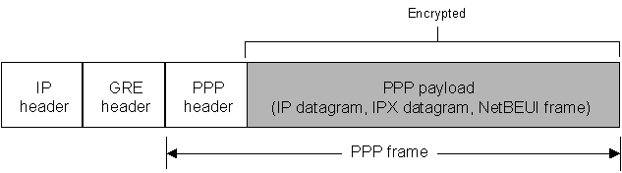
Figure 1.2
Layer 2 Tunneling Protocol (L2TP)
L2TP is also a layer 2 protocol with a combination of PPTP and L2F (Layer 2 Forwarding), a technology developed by Cisco Systems, Inc. L2TP encapsulates PPP frames to be send over IP, X.25, Frame Relay, or Asynchronous Transfer Mode (ATM) networks. L2TP over IP Internetwork uses User Datagram Protocol (UDP) and a series of L2TP messages for tunnel maintenance. It also uses UDP to send L2TP encapsulated PPP frames as the tunneled data. The payloads of encapsulated PPP frames can be encrypted and/or compressed. Figure 1.3 shows the structure of an L2TP packet containing user data. “In Windows 2000, IPSec Encapsulating Security Payload (ESP) is used to encrypt the L2TP packet” (Microsoft Corp, 13). This is known as L2TP/IPSec and is used in secure VPN technology.

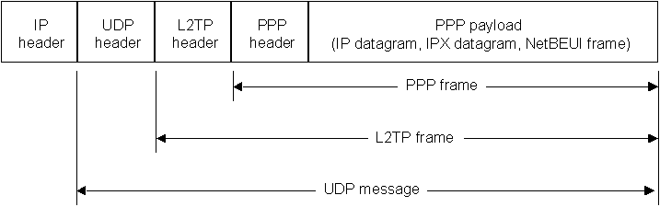
Figure 1.3

IPSec Tunnel Mode
Unlike the other two protocols, IPSec is a layer 3 protocol standard that supports a secure transfer of information across an IP Internetwork. “In addition to its definition of encryption mechanisms for IP traffic, IPSec defines the packet format for an IP over IP tunnel mode, generally referred to as an IPSec Tunnel mode” (Microsoft Corp., 14). An IPSec tunnel consists of a tunnel client and a tunnel server, which are both configured to use IPSec tunneling and a negotiated encryption mechanism. The encrypted payload is then encapsulated again with a plain-text IP header and sent over the Internetwork for delivery to the tunnel server. When the tunnel server receives the packet, it discards the plain-text IP header and then decrypts its contents to retrieve the original payload IP packet. This packet is then processed normally and routed to its destination on the target network. However, IPSec tunnel mode comes with the following features and limitations.

- It supports only IP traffic.
- It functions at the bottom of the IP stack.
- It is controlled by a security policy - a set of filter-matching rules.

Conclusion
In conclusion, VPN is a technology devoted to provide transmission of data end-to-end using firewalls, encryption, authentication, and tunneling mechanisms. Its popularity is growing along with the Internet and its usefulness is highly appreciated by corporations and organizations where remote access is an utmost necessity. However, despite its growth, its risks of using the public internetwork are inevitable. It is considered to be wiser for VPN users to expect security breaches to happen than not in this insecurely, vulnerable technology-driven society. And it is even best to be informed of the security loopholes in existence and utilize some common sense to keep up with the security issues in this insecure reality. Therefore, VPN is a technology that is reliable enough to transmit information end-to-end over the public internetwork, but it can never be completely trusted upon for its transmission yet.

Works Cited

Brown, Steven. Implementing Virtual Private Networks McGraw-Hill Publishers 1999.

Cisco Sytems, Inc. How Virtual Private Network works 1992 - 2002 http://www.cisco.com/warp/public/471/how_vpn_works.shtml.

Microsft Corp. Virtual Private Networking in Windows 2000: An Overview 2000
http://www.microsoft.com/windows2000/docs/VPNoverview.doc.

Scott Charlie, Wolfe Paul and Erwin Mike. Virtual Private Networks, 2nd Edition Oreilly Publishers 1999.

Virtual Private Networks Consortium. VPN-technologies: Definitions and Requirements June, 2002 http://www.vpnc.org.

