Name: Arshiya Khan
Class: Cs 265
Semester: Spring 2004
Report on Gait Recognition

Gait Recognition
Abstract:
In today’s world, there is a growing need to authenticate and identify individuals automatically. Securing personal privacy and deterring identity theft are national priorities. Biometrics is a technology that makes use of the physiological or behavioral characteristics of people to authenticate their identities. It can accurately identify or verify individuals based upon their unique physical or behavioral characteristics. This paper is a brief report about gait recognition

Introduction:
Vision –based human identification at a distance is in higher demand in computer vision community. This demand is strongly driven by the need for automated person identification systems for visual surveillance and monitoring applications. The art and science of biometrics is all about coming up with an all-purpose personal identifier. Biometric authentication is the "automatic", "real-time", "non-forensic" subset of the broader field of human identification. Humans recognize each other according to their various characteristics. For example, people recognize others by their face when they meet them and by their voice as they speak to each other. Identity verification in computer systems has traditionally been based on something that one has or one knows.

A biometric system is essentially a pattern recognition system that establishes a person’s identity by comparing the binary code of a uniquely specific biological or physical characteristic to the binary code of the stored characteristic. This is accomplished by acquiring a live sample from an individual who is requesting access. The system then applies a complex and specialized algorithm to the live sample and converts it into a binary code and then compares it to the reference sample to determine the individual's access status. A profile or template containing the biometrical properties of a person is stored in the system (generally after data compression), by recording his characteristics. These characteristics are scanned several times during enrolment in order to get a profile that corresponds most with reality. A scan of the biometrics of a person is made and compared with the characteristics that are stored in the profile
Classifications:
There are various ways to classify biometric systems and devices.
Biometric systems: These systems can be used in two different modes:
- Verification
- Identification.
Identity verification occurs when the user claims to be already enrolled in the system, and the biometric data obtained from the user is compared to the data stored in the database. Identification, on the other hand, occurs when the identity of the user is a priori unknown. The user’s data is matched against all the records in the database. Identification is technically more challenging and costly [5].
Biometric devices: These are classified according to two distinct functions:
- Positive Identification: To prove a person is enrolled in the system.
- Negative Identification: To prove a person is not enrolled in the system.
These functions are "duals" of each other. In the first function, the present person is linked with an identity previously registered, or enrolled, in the system. The second function, establishes that the present person is not already present in the system. The purpose of this negative identification system is to prevent the use of multiple identities by a single person. If a negative identification system fails to find a match between the submitted sample and all the enrolled templates, an "acceptance" results. A match between the sample and one of the templates results in a "rejection"[5].
Examples of Biometrics are Fingerprint, Handwritten signature, Facial recognition, Speech recognition, Gait recognition etc.
Gait recognition aims to discriminate individuals by the way they walk. In comparison with other first-generation biometric features such as fingerprint and iris, gait has the advantage of being unobtrusive, i.e., it requires no subject appearance and the dynamics of human walking motion. i.e. recognizing people by gait depends greatly on how the silhouette shape of an individual changes over time in an image sequence. Gait motion is composed of a sequence of static body poses and it is expected that some distinguishable signatures with respect to these static body poses can be extracted and used for recognition. Each person seems to have a distinctive and idiosyncratic way of walking, which can be easily understood from a biomechanics viewpoint.

In this paper we aim to discuss about an automatic gait recognition method based upon spatiotemporal silhouette analysis measured during walking Intuitively, recognizing people by gait depends greatly on how the silhouette shape of an individual changes over time in an image sequence. So, we may consider gait motion to be composed of a sequence of static body poses and expect that some distinguishable signatures with respect to those static body poses can be extracted and used for recognition by considering temporal variations of those observations. Also, eigenspace transformation based on PCA has actually been demonstrated to be a potent metric in face recognition (i.e., eigenface) and gait analysis. Based on these observations, this paper discusses about a proposal made by some people on a silhouette analysis-based gait recognition algorithm using the traditional PCA. The algorithm implicitly captures the structural and transitional characteristics of gait [2]

Background Modeling

Motion Segmentation
Human Tracking
Silhouette Extraction
2D Silhouette Unwrapping
1D Signal Normalization
Projection in Eigenspace
Recognition
Eigenspace Computation
Human Detection & Tracking
Feature Extraction
Training or Classification

The overview of the proposed algorithm is shown in Figure above. It consists of three major modules, namely, human detection and tracking, feature extraction, and training or classification. The first module serves to detect and track the walking figure in an image sequence. A background subtraction procedure is performed to segment motion from the background, and the moving region corresponding to the spatial silhouette of the walking figure is successively tracked through a simple correspondence method. The second module is used to extract the binary silhouette from each frame and map the 2D silhouette image into a 1D normalized distance signal by contour unwrapping with respect to the silhouette centroid. Accordingly, the shape changes of these silhouettes over time are transformed into a sequence of 1D distance signals to approximate temporal changes of gait pattern. The third module either applies PCA on those time-varying distance signals to compute the predominant components of gait signatures (training phase), or determines the person’s identity using the standard nonparametric pattern classification techniques in the lower-dimensional eigenspace (classification phase)[2].

FEATURE EXTRACTION
Before training and recognition, each image sequence including a walking figure is converted into an associated temporal sequence of distance signals at the preprocessing stage. The various procedure in feature extraction are explained below

Human Detection and Tracking
Human detection and tracking is the first step to gait analysis. To extract and track moving silhouettes of a walking figure from the background image in each frame, the change detection and tracking algorithm is adopted which is based on back-ground subtraction and silhouette correlation. The main assumption made here is that the camera is static, and the only moving object in video sequences is the walker.

Background Modeling
Background subtraction has been widely used in foreground detection where a fixed camera is usually used to observe dynamic scenes. Here, the LMedS (Least Median of Squares) method is used to construct the background from a small portion of image sequences even including moving objects. Let I represent a sequence including N images. The resulting background b_{xy} can be computed by
b_{xy} =min med _{t}(I^{t}_{xy}-p)²

where p is the background brightness value to be determined for the pixel location (x;y) , med represents the median value, and t represents the frame index ranging within 1-N, where N=60.

Silhouette Representation

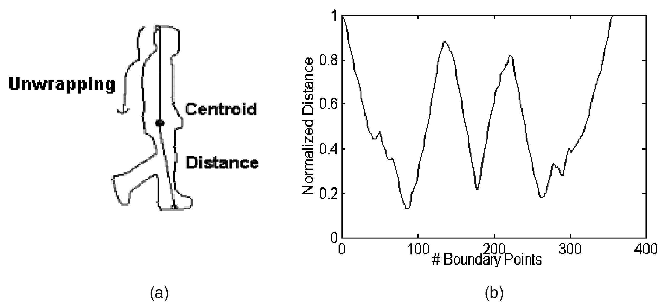

In order to obtain computational efficiency, these 2D silhouettes are changed into an associated sequence of 1D signals to approximate temporal pattern of gait. After the moving silhouette of a walking figure has been tracked, its outer contour can be easily obtained using a border following algorithm. Then, we can compute its shape centroid (x_{c,}y_{c}). By choosing the centroid as a reference origin, we unwrap the outer contour counterclockwise to turn it into a distance signal S={d₁,d₂,…….,d_{i}…..d_{nb}} that is composed of all distances d_{i} between each boundary pixel (x_{i},y_{i}) and the centroid.
d_{i}=((x_{i}-x_{c})²+(y_{i}-y_{c})²)^{1/2}

RECOGNITION
Gait is a kind of spatiotemporal motion pattern, so a STC (Spatial-Temporal Correlation, an extension of 2D image correlation to 3D correlation in the space and time domain) is used to better capture its spatial structural and temporal transitional characteristics. Gait period analysis is done to determine the frequency and phase of each observed sequence so as to align sequences before matching. For an input sequence (Fig a) once the person has been tracked for a certain number of frames, its spatiotemporal gait parameters such as the aspect ratio signal of the moving silhouette can be estimated (Fig b) .In the next step of the process background component is removed by subtracting its mean and dividing by its standard deviation, and then smooth it with a symmetric average filter (Fig c). Further, next step computation of its autocorrelation is done to find peaks (Fig d). Finally, computation of its first-order derivative(Fig e) is done to find peak positions by seeking the positive-to-negative zero-crossing points (Fig f). Due to the bilateral symmetry of human gait, the autocorrelation will sometimes have minor peaks half way between each pair of major peaks. Hence, estimation of the real period is done as the average distance between each pair of consecutive major peaks.

CONCLUSIONS
With the increasing demands of visual surveillance systems, human identification at a distance has recently gained more interest. Gait is a potential behavioral feature and many allied studies have demonstrated that it has a rich potential as a biometric for recognition. The development of computer vision techniques has also assured that vision-based automatic gait analysis can be gradually achieved.

The algorithm discussed in this paper is based on silhouette analysis, so it is inevitably subject to the effects of different types of clothes. Creating more reference sequences with different clothes may be of use to solve this problem. The lack of generality of viewing angles is a limitation to most gait recognition algorithms. We can generalize the algorithm by storing the training sequences taken from multiple viewpoints and to classify both the subject and the viewpoint.

References:
1: “A Newly Emergent Study: Gait Recognition “
http://www.sinobiometrics.com/gait.htm
2: “Silhouette Analysis-Based Gait Recognition for Human Identification”
by Liang Wang, Tieniu Tan, Senior Member, IEEE, Huazhong Ning, and Weiming Hu

http://www.sinobiometrics.com/publications/lwang/PAMI.pdf

3: “Gait Recognition Using Static, Activity-Specific Parameters “
by Aaron F. Bobick & Amos Y. Johnson

http://www.cc.gatech.edu/cpl/amos/mypapers/cvpr2001_Gait.pdf

4: “Automatic Gait Recognition for Human ID at a Distance”
http://www.gait.ecs.soton.ac.uk/
5: “ Biometrics” by Soumyadip Rakshit
http://jiskha.com/science/biology/biometrics.html

