Name: Shefali Jariwala
Student ID: 001790660
CS – 265 Project Report
Section: 2 (11:30 – 12:20 )
Due: 5th April, 2004

Enhancing Wireless Security with WPA

This report talks about enhancing wireless security with WPA. The report begins with discussing overview of WLAN, WEP protocol and its weaknesses. Further discussion continues with the promise of WPA, its modes of operation and security mechanisms, upcoming WPA2 technology and report ends with final conclusions.

Enhancing Wireless Security with WPA
Overview of WLAN
WLAN has no wires and its components are wireless clients and access points (AP). An AP and a wireless client can talk to each other only if they use the same SSID (system set identifier) and when a wireless client is configured it finds out all the available AP’s and has an option of choosing which AP to connect. Various IEEE standards are 802.11(1-2 Mbps speed), 802.11a
(54 Mbps speed), 802.11b (11Mpbs), 802.11g (54 Mbps). Wi-Fi stands for wireless fidelity and is a generic term for referring to any of the above 802.11 standards. Wireless security is based on encryption, data privacy, authentication and access control.
WEP is one of the security mechanisms for 802.11 networks. It is an encryption algorithm designed to protect wireless communication from unauthorized reading (confidentiality), unauthorized access to a wireless network (access control/authentication) and unauthorized tampering/modification/writing (data integrity). Both WEP authentication and encryption are based on a secret key shared between AP and wireless client. The same secret key is distributed to all wireless clients and access points within a WLAN.
WEP Security Mechanism
WEP uses RC4 stream cipher of 64 bit = 40 bit WEP key + 24 bit (IV) to encrypt the data. IV is randomly generated with every message so every time a new encryption key is generated. The sender XOR’s the stream cipher with actual data to produce the cipher text. The packet together with the IV and the cipher text is sent to the receiver. The receiver decrypts the packet using the stored WEP key and attached IV.
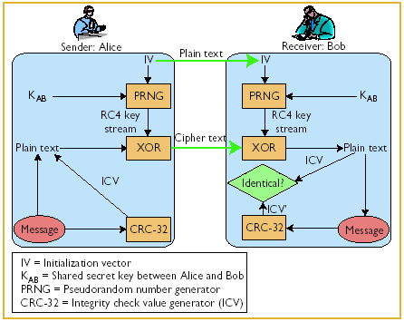
Client
Access Point
Authentication request
Random challenge
Encrypted RC
Success/failure response
Figure 1: WLAN security: Current and Future, Figure 2: WEP Authentication (PSK)
Park, J.S; Dicoi, D.; IEEE Internet Computing,
Volume: 7, Issue: 5, Sept-Oct, 2003, 60-65
WEP Encryption
Sender: WEP key 64 bits = 40 bits + IV (24 bits) fed into the pseudo random number generator (PRNG) RC4 key stream is created using the PRNG to increase randomization. XOR the key stream with plaintext to generate cipher text. The IV is transferred in the header as plaintext. The CRC-32 is appended to the cipher text and then encrypted.
Receiver: The IV is obtained from the header and WEP Key (shared) + IV used as input to PRNG, RC4 key stream is created using the PRNG. The cipher text is decrypted using the key stream and the CRC-32 value which is calculated is compared to the CRC stored in message.
WEP Authentication
- Open System (No Authentication - all users are allowed to access the wireless network)
- Shared key (Refer Figure 2)
In shared key mode first the client sends authentication request to the AP. The AP sends a random challenge to the client. The client encrypts the random challenge with the shared secret and sends it to AP. Now the AP decrypts the encrypted challenge from client and compares to the original challenge it had sent and finally the AP sends the success/failure response to the client.
WEP Weaknesses
- A single key is used for all AP’s and wireless clients. It allows the attacker to discover the default key being used by the AP’s and the clients. And he can decrypt all the messages being sent over the encrypted channel.
- It uses Static WEP key – it relies on manual key entry and distribution but still there is chance of mistakes so the solution proposed was to have a Dynamic WEP key – The idea was to generate automatically short-lived WEP keys at a certain interval. This might prevent the attackers from eaves dropping the communications. And would not be able to collect enough data to crack WEP keys.
- The same key is used for both authentication and encryption so if the attacker somehow gets the shared key then he can use it to access the network as well as use it for viewing other person’s data.
- Initialization Vector (IV) Reuse:
The IV (24-bit) and WEP key are used to create the key stream, which is used to transform the plaintext into cipher text known as WEP encrypted frame. On a busy network IV will wrap and be reused. When this happens and the WEP key is not changed frequently there is a compromise in the security of the network because one can retrieve the plaintext with some effort.
It allows the attackers to retrieve the plaintext without knowing the actual key. E.g. we know that some characters are used more than others, so when a text file is being sent over the encrypted channel the attacker has some clues as to the distribution of the characters in the originating plaintext. Any two messages using the same IV can be reduced to the following:
Ci = Pi ⊕ ksi
Ci’= Pi’ ⊕ ksi’ Therefore, Ci ⊕ Ci’= Pi ⊕ Pi’
Since both the cipher texts are known the attacker simply tries combinations of Pi and Pi’ such that they get equal the result of Ci ⊕ Ci’.
- Known Plain text attacks
The attacker can determine the key stream by sending messages which contain known plaintext over an encrypted channel.
- WEP provides no replay protection
An attacker can keep track and record WEP packets and then retransmit them later. This kind of attack helps the attacker to get some information about the encryption key and the plain text.
WPA – Wireless Protected Access - A Promise
Wi-Fi Alliance is an association to certify interoperability of WLAN products based on IEEE 802.11 specifications. WPA is a specification from Wi-Fi Alliance. It offers a stronger security solution. The base for WPA is 802.11i standard and it is forward-compatible. It increases the level of data protection and access control for WLANs. WPA runs as a software upgrade on existing hardware (APs and NICs). It is designed to minimize impact on network performance. It is inexpensive in terms of cost/time to implement and addresses all WEP weaknesses to ensure data authentication and protection against attackers on WLANs. WPA is designed to secure all versions of 802.11 devices including 802.11b, 802.11a and 802.11g.
WPA – Modes of Operation (Enterprise and Pre-Shared Key Mode)
Enterprise mode is used for corporate users, requires an authentication server (RADIUS - Remote Authentication Dial-In User Service) for authentication and key distribution and it has centralized management of user credentials. It holds user credentials like usernames and passwords and authenticates wireless users before they gain access to the network. (Refer Figure 3)
Pre-Shared Key Mode is used for home and small office/home office (SOHO) users, does not require authentication server, a “shared secret” is used for authentication to access point and it is vulnerable to dictionary attacks. (Refer Figure 3)
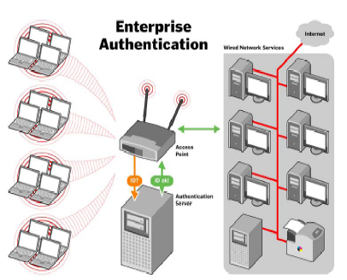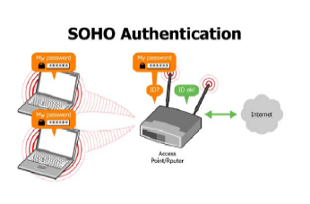
Figure 3:http://www.wi-fi.org/opensection/pdf/whitepaper_wi-fi_security4-29-03.pdf
However there are some implementation issues related to Pre-Shared key Mode:
- PSK is needed when no authentication server is in use
- If shared secret is revealed or known then the network security may be compromised
- There is no standardized way of changing shared secret
- It increases the attacker effort to do decryption of messages.
- The more complex the shared secret is, the better it is as there are less chances of dictionary attacks
Security Mechanisms in WPA
- WPA can be expressed as a combination of all these 4 technologies.
- Strong user – based authentication by using 802.1x standard and Extensible Authentication Protocol (EAP)
- Robust encryption through 128 – bit encryption keys and use of Temporal Key Integrity Protocol (TKIP) – dynamic generation of encryption keys
- Message Integrity Check (MIC) prevents an attacker from capturing and altering data packets. RADIUS allows access control by allowing only authorized clients onto the network.
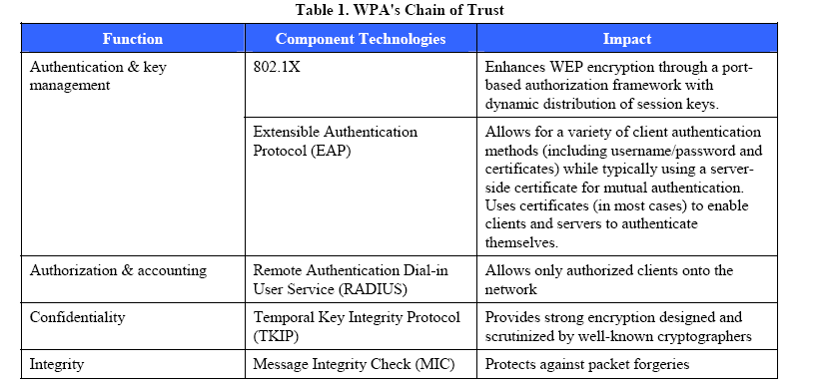
Table 1: http://www.intel.com/ebusiness/pdf/wireless/intel/wpa_cmt_security.pdf

802.1X Authentication prevents end users from accessing Enterprise networks
WPA adopts 802.1X standard to authenticate user. This standard provides access control and mutual authentication between the wireless clients and access points via RADIUS. Here:
- Using EAP an end-user contacts a wireless access point and requests to be authenticated
- The Access point passes the request to the RADIUS server
- The RADIUS server challenges the end user for a password and the end user responds with a password to the RADIUS Server
- The RADIUS server authenticates the end user and the access point open a port to accept data from the end user. (Refer Figure 4)
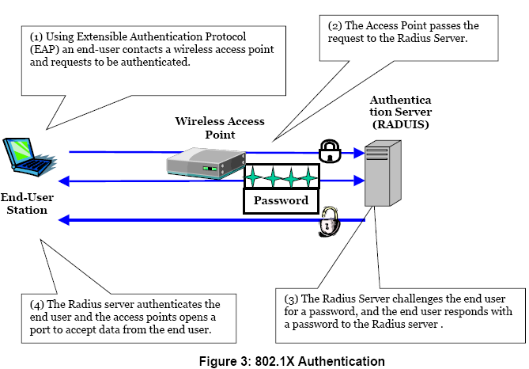
Figure 4: http://www.mtghouse.com/MDC_WP_052603.pdf
Mutual Authentication:
- The end-user initiates the connection with the wireless access point (authenticator).
- The authenticator detects the initiation and enables the port of the supplicant. At this point the port state is unauthorized. All the traffic except 802.11X including HTTP, FTP, and SMTP etc is blocked. The authenticator requests the identity from the supplicant. The supplicant responds with the identity and the authenticator forwards the identity to RADIUS. The RADIUS authenticates the identity of the supplicant and sends a response either ACCEPT or REJECT message. The AP changes the supplicant’s port to authorized state.
- The supplicant then requests the identity from the authentication server and the server passes its identity to the supplicant. Once the supplicant authenticates the identity of the authentication server, the conversation begins.
As a part of this process, a Pair wise Master Key (PMK) is generated on the end user station and RADIUS server and the server sends the PMK to the AP. Here, PMK is used to generate transient keys which will be used in encryption. The PMK is never directly involved in generating key streams for encryption which prevents weak key attacks.

TKIP – Temporal Key Integrity Protocol
TKIP is responsible for generating the encryption key, encrypting the message and verifying its integrity. It adds more enhancements to the actual encryption performed using the same RC4 algorithm (used in WEP). It ensures that encryption key changes with every packet and that it is unique for every client. TKIP encryption key size = 256 bit, TKIP packet is comprised of 3 parts:
- A 128 bit temporal key that is shared by both the clients and the access points
- Client Device MAC Address
- 48-bit IV describes a packet sequence number (This prevents known plain text attacks)
TKIP generates a per packet key by TKIP key mixing function and uses the temporal key. The client device’s MAC address is mixed with the temporal key and the four most significant octets of the packet sequence number. And that is used as an index into an S-box to generate an intermediate key. When you mix up the client device’s MAC address with the temporal key, it results in a unique encryption key. Thus, different wireless client have different keys. In the second phase, a cipher is used to mix the intermediate key with the two least significant octets of the packet sequence number and generates a 128 bit per-packet key. Thus, each key encrypts only one packet of data and prevents weak key attacks.
Michael Message Integrity Check (MIC) – enforces data integrity
MIC provides strong mathematical function (Michael’s algorithm) - The sender and the receiver each compute MIC and then compare. If MIC does not match then it means that the data is manipulated or forged. MIC preserves both source and destination addresses so the data packets cannot be manipulated and resend to unauthorized destinations. It uses the 64-bit key and partitions the data into 32-bit blocks. Various operations of shifts, XOR’s, and additions and stores the result in two 32-bit registers which is the MIC.
Drawbacks of WPA - Service may be denied for about 60 seconds
It is vulnerable to denial-of-service attacks (DOS). If the access points receive two data packets that fail the MIC check within 60 seconds then the network is prone to an active attack. The solution to that is having a counter measure for access points which disassociates each client using the AP. This prevents the attacker from getting the information about encryption keys.

Upcoming WPA2 (Wi – Fi Protected Access version2)
Uses the Advanced Encryption Standard (AES), Symmetric Key = 128 bit key and it has full 802.11i support including Counter Mode with CBC-MAC Protocol (CCMP) encryption.
CCMP = CTR + CBC + MAC (CTR = Counter Mode Encryption, CBC = Cipher Block Chaining, MAC = Message Authentication Code). It will require new Hardware (AP’s and NIC’s) and the certified Equipments are expected to be due in late 2004. [The notes and slides for WPA2 are almost identical to the slide available on this web-site for understanding purpose]
http://www.wi-fi.org/opensection/pdf/Wi-Fi_ProtectedAccessWebcast_2003.pdf
Encryption Method Comparison Table

Table 2: http://www.wi-fi.org/opensection/pdf/Wi-Fi_ProtectedAccessWebcast_2003.pdf

Conclusions
WPA solves almost all WEP weaknesses. WEP is not secure anymore, WPA still considered secure and provides secure authentication, encryption and access control, it is not yet broken….!
WPA2 is even stronger cipher than WPA and will provide robust security.

References
WLAN security: Current and Future, Park, J.S; Dicoi, D.; IEEE Internet Computing, Volume:7, Issue:5, Sept-Oct, 2003, 60-65
Wireless networking security: Security flaws in 802.11 data link protocols, Nancy Cam-Winget, Russ Housley, David Wagner, Jesse Walker; Communications of the ACM-Volume 46, Issue 5 (May 2003), Pages 35-39
http://www.cizgi.com.tr/makaleler/seminer/S2-1.pdf
http://www.dtm.ca/download/wireless_toshiba.pdf
http://www.intel.com/ebusiness/pdf/wireless/intel/wpa_cmt_security.pdf
http://www.mtghouse.com/MDC_WP_052603.pdf
http://www.sans.org/rr/papers/68/1109.pdf
http://www.sans.org/rr/papers/68/1301.pdf
http://www.wi-fi.org/opensection/pdf/whitepaper_wi-fi_security4-29-03.pdf
http://www.wi-fi.org/opensection/pdf/Wi- Fi_ProtectedAccessWebcast_2003.pdf
http://www.hackfaq.org/wireless-networks/wpa-wi-fi-protected-access.shtml
http://techrepublic.com.com/5100-6265-5060773.html

