Brandon Hunter
4/5/2004

CS 265
Mark Stamp
Inner Workings of The German Enigma

In 1918 a German man named Albert Scherbius first conceived of a machine that would use electro-mechanical properties in order to encrypt messages. The machine that Scherbius conceived of would pass an electrical current through rotating rotors in order to encrypt messages. Scherbius took his machine to the German military but they weren’t sure of its usefulness at the time and were not interested. Since the military wasn’t interested, Scherbius sold his machine to a German company called Gewerkschaft Securitas who bought the patent. In 1920 Gewerkschaft Securitas produced the first Enigma machine (Schwager). The original Enigma machine was constructed of several main components: a keyboard, three rotors, a reflector, and a light board (See Picture 1). By 1925 the German military started buying the Enigma machine in order to encrypt radio messages. The military made some modifications to the machine such as adding or deleting keys, adding a plug board, and adding more rotors in order to increase security.
The Enigma machine was adopted very quickly by the German military because it was both difficult to break the encryption code and easy to use, even by someone with no knowledge of cryptography (Jacobs, 76). The operators would set the Enigma to a predetermined initial setting that was established by following a schedule (See Picture 2). The initial settings of the machine are essentially the key for the machine. At the start of WWII the schedule was published once a month but later it became necessary to change it weekly, then daily or more. The schedule consisted of several settings that would have to be synchronized in order for the machine to work, such as rotor sequence, plug board wiring, alphabet ring settings, and initial positions (Wikipedia). The Enigma machine is symmetrical in the sense that it would decrypt a message in the same way that it would encrypt a message given that you started with the same initial settings.
The Enigma machine is considered an electro-mechanical machine because it consists of a combination of electrical and mechanical based components. The main mechanical properties of the Enigma machine are gears that are driven by pressing the keys on a typewriter style keyboard. The keyboard would also operate electrical switches that would initiate a current through the machine. A battery that would be attached to the machine would generate the electricity. The main components of the Enigma are the rotors (See Picture 3). Each rotor is a flat disk with 26 electrical contacts that correspond to the letters of the alphabet. The 26 electrical contacts are arranged in a circular pattern around the outer face of the flat disk. Each contact on one face of the disk is wired to a different contact on the opposite side of the disk. This allows an input alphabet on one side of the disk to be mapped to a different output alphabet on the opposite side of the disk. For example contact 5 on one side of the disk might be mapped to contact 21 on the opposite side. Each Enigma machine was supplied with a set of rotors, each of which were wired differently but only a set of 3 rotors would be used in the machine at a time (See Picture 4). The 3 rotors would fit into slots inside the machine in a cascading manner where the output to the first rotor would be the input to the second rotor and the output of the second rotor would then be the input to the third rotor. The output to the third rotor would be connected to a device called a reflector, which would send the current back through the third rotor in the opposite direction and through a different route. The current would then go through the second rotor and back to the first rotor. Every time a key is pressed the first rotor would advance one position. After the rotor had been advanced 26 times, one full rotation, then the second rotor would advance one position. After the second rotor advanced 26 times then the third rotor would advance.
Another component of the Enigma machine is the plug board. The operator would make connections on the plug board that would re-map certain letters of the alphabet. For example, if the operator made a connection between the letters “A” and “Z” then the letter “Z” would be used in place of “A” and “A” would be used in place of “Z”. If no connections were made on the plug board then this portion of the Enigma would not do anything. The plug board is used to do an initial and final permutation.
The output of the Enigma would be displayed on a component called the light board. The light board would light up the letter that corresponds to the resulting cipher text after the Enigma went through all its operations.
When a key on the keyboard is pressed the machine would start by generating a current that would be electrically switched to correspond to a letter of the alphabet. As the current passed through each component of the Enigma the letter would get remapped to another letter of the alphabet. The first component that the current would go through is the plug board. If any connections were made on the plug board, the letters corresponding to the connections would be remapped. If no connections were made then the current would travel to the first rotor. The first rotor would perform a one-to-one alphabet mapping and then the current would go through the second rotor. The second rotor would then again perform a different one-to-one alphabet mapping and the current would go to the third rotor. The third rotor would again perform a different one-to-one alphabet mapping. After the third rotor the current would hit the reflector where it would get reversed and send back through the rotors but through a different route. So the reflector once again remapped the alphabet and as the current traveled back through the three rotors the alphabet remapped three more times for each rotor (See Picture 5). The current then goes back through the plug board where it remapped the alphabet if any connections were present. Finally the resulting cipher text gets displayed on the light board (Schwager).
The Enigma has a total of 9 alphabet permutations that occur through the process of encrypting a message. Additionally since the Enigma has 3 rotors, each of which have 26 letters, the Enigma has a library of 26 x 26 x 26 = 17576 substitution alphabets for any particular ordering of the rotors. But since the three rotors can be rearranged into any of the three slots in the machine there are another 3 x 2 x 1 = 6 combinations. So there are a total of 6 x 17576 = 105,456 possible alphabets (Wikipedia). The Germans thought the Enigma machine was sufficiently secure that it could not be cracked in a reasonable amount of time. Finding the proper positions of the rotors from the 105,456 possible positions seemed impossible. It wasn’t until 1929 when the Polish government intercepted an Enigma machine being sent from Berlin to Warsaw that the inner workings of the machine were understood.
The Enigma machine helped advance the field of cryptography because it was one of the first cryptographic machines that was both easy to use and quite secure. There was a breakthrough in the use of electro-mechanics to change the alphabet after each letter was entered. This made the machine much more secure against frequency count attacks. The amount of human resources that went into the efforts to crack the Enigma machine increased the study of cryptanalysis dramatically. The British government started a school called the “Government Code and Cypher School (GC&CS)” at Bletchley Park. Such study of the subject is the basis for the class we are in now.

Bibliography

Bletchley Park Museum. (Picture 2). http://www.codesandciphers.org.uk/enigma/enigma3.htm. Online
Hinsley, Sir Harry. “The Influence of ULTRA in the second World War.”
http://www.cl.cam.ac.uk/Research/Security/Historical/hinsley.html. Online. 1993
Hodges, Andrew. (Picture 5)
http://www.trincoll.edu/depts/cpsc/cryptography/enigma.html. Online. 1983
Jacobs, William. “Enigma-E Electronic Enigma Machine.” Discover Magazine May
2004: 76.
Olsen, Reidar. (Picture 4) http://webhome.idirect.com/~jproc/crypto/enigma.html.
Online
Proc, Jerry. (Picture 1). http://webhome.idirect.com/~jproc/crypto/enigma.html. Online
Proc, Jerry. (Picture 3). http://webhome.idirect.com/~jproc/crypto/enigma.html. Online
Schwager, Russell. “History of the Enigma Machine.”
http://www.ugrad.cs.jhu.edu/~russell/classes/enigma/history.html. Online.
1998-2003
Schwager, Russell. “How does the Enigma work?”
http://www.ugrad.cs.jhu.edu/~russell/classes/enigma/how.html. Online.
1998-2003
Wikipedia, Free Encyclopedia. “Enigma Machine.”
http://en.wikipedia.org/wiki/Enigma. Online.

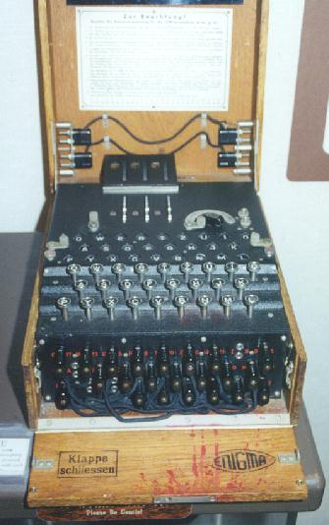

Picture 1: Enigma Machine

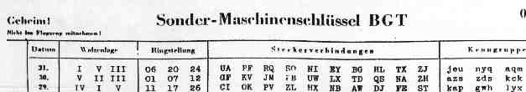

Picture 2: Enigma Setting Schedule

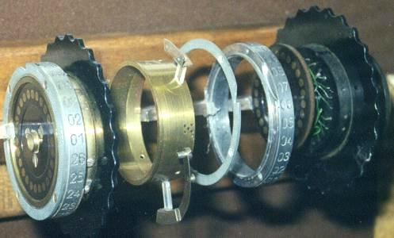

Picture 3: Disassembled Rotor

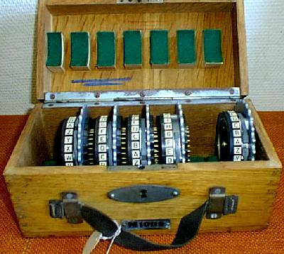

Picture 4: Set of Rotors

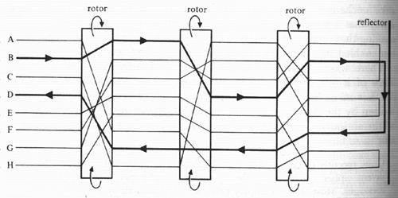

Picture 5: Alphabet Mapping

