Project
CS265 Cryptography and Computer Security

Rakesh Sharma
SJSU Id: 003885259

Table of Contents
1 Project Description 3
1.1 Introduction 3
1.2 Program Description 4
1.3 Program Usage 5
1.4 Program Output 6
1.5 Hide IP addresses in SMTP headers 7
1.5.1 Blind/Open Relays 7
1.5.2 Buffer Overflow 8
2 References 8

Project Description

Introduction

The project is the design and development of a simple spam tool. It allows a user to send an email as a fictious user from a fictious domain. The program is an implementation of the Simple Mail Transfer Protocol (SMTP) protocol.

Simple Mail Transfer Protocol Description
The objective of the Simple Mail Transfer Protocol (SMTP) is to transfer mail reliably and efficiently.

A user or application composes a message containing the recipient e-mail address (for example, "someone@somewhere.com") along with the subject and content of the message.

Delivery of the message is initiated by transferring the message to a designated SMTP server. Based on the domain name of the recipient e-mail address (for example, "somewhere.com"), the SMTP server initiates communications with a Domain Name System (DNS) server, which looks up and returns the host name of the destination SMTP server (for example, "mail.somewhere.com") for that domain.

Finally, the originating SMTP server communicates with the destination SMTP server directly through Transmission Control Protocol/Internet Protocol (TCP/IP) port 25. If the user name of the recipient e-mail address matches one of the authorized user accounts in the destination server, the original e-mail message will eventually be transferred to that server, waiting for the recipient to pick up the message through a client program.

In the case where the originating SMTP server cannot communicate directly with the destination server, the SMTP protocol provides mechanisms to transfer messages through one or more intermediate relay SMTP servers. A relay server will receive the original message and then attempt to deliver it to the destination server or redirect it to another relay server. This process will be repeated until the message is delivered or a designated timeout period passes.

Program Description
The program is an implementation of the Simple Mail Transfer Protocol (SMTP) protocol. The application was developed using Microsoft Foundation Classes and Visual Studio .NET. The source code and the executable (“Spam Text.exe”) have been provided on a CDROM.

The screen layout of the Spam Test application is shown below-

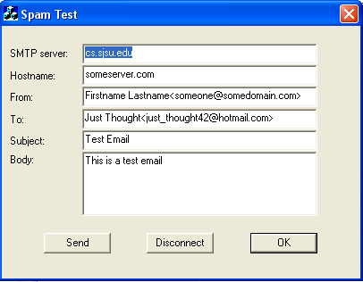

Field Description

- SMTP server – This is the name of the gateway email server through which the email will be “relayed” to the destination server (hotmail.com). The assumption is that the instructor will test the application within the SJSU LAN, so the server name is kept as “cs.sjsu.edu” and the field should be left as is. This server should be “pingable” because the application tries to contact the server directly to send email. Since the SJSU LAN is protected by a firewall, any servers outside the LAN cannot be reached directly.
- Hostname – This is the name of the originating PC (from where the mail was composed and sent) that will be visible in the SMTP header of the recipient.
- From – The originating name and email id that will be visible to the recipient in his/her email.
- To – The recipient name and email id. For test purposes, I have created a test email id called just_thought42@hotmail.com. The password for the same is “hello12”.
- Subject and Body – Subject and body of the email

Program Usage
The program usage is simple:-
- Log onto the SJSU LAN using your network id.
- Start the “Spam Test” application
- Fill in the the Subject and Body fields.
- Click on the “Send” button. If the application has successfully contacted the SMTP gateway, it will send the email and prompt the user with a success message (below).

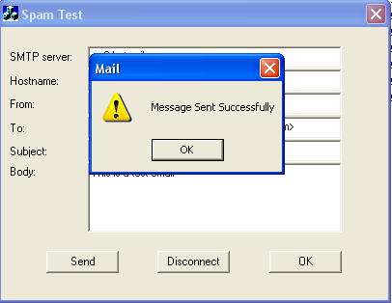

- Log onto www.hotmail.com using “just_thought42” login and “hello12” as password. Check whether the email has been received with the desired output.

Program Output

A sample program output is shown below. This is one of the emails received at the end user’s hotmail account -

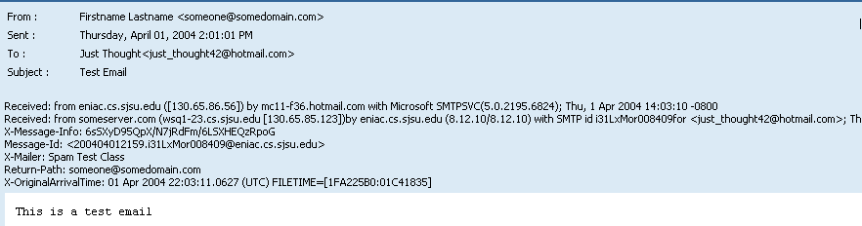

Conclusions-
- The From, To, Return Email Id and originating PC name (circled in red above) fields are received correctly. Although an SMTP service allows an SMTP client to negotiate a security level with a mail server, this precaution is not often taken. Therefore, anyone with the requisite knowledge can connect to the server and use it to send messages. To send spam e-mail, senders insert text in headers that will alter message information, as in the example above.
- However, the IP address of the PC is clearly visible on the SMTP header (circle in blue). The procedure to hide the IP address is more involved and involves manipulating data at the network layer instead of the application layer. A commonly used concept is described in the next section. It is to be noted here that many spammers use dynamic IP addresses assigned by their ISP. Therefore, detection of IP address in the “spammed” message header at the destination is not a cause of serious concern for them, unless a complaint is lodged at the originating ISP who then tries to map the IP address with the hardware (MAC) address from the sendmail logs to trace the spammer.

Hide IP addresses in SMTP headers

Blind/Open Relays
An open relay (sometimes called an insecure relay or a third-party relay) is an SMTP e-mail server that allows third-party relay of e-mail messages. By processing mail that is neither for nor from a local user, an open relay makes it possible for an unscrupulous sender to route large volumes of spam. In effect, the owner of the server -- who is typically unaware of the problem -- donates network and computer resources to the sender's purpose. Spammers are able to locate accessible third-party mail relay servers by using automated tools that are readily available on the Internet.
A blind relay is a relay that hides (modifies) the IP address of the sender. These typically run on UNIX servers and are modified versions of sendmail daemons/drivers. The SMTP service forges the SMTP header by changing the originating IP/ISP information, and then relays the message to the destination. A blind relay ultimately is noticed by the anti-spam community and may be put on the block list, but the provider of such a service would have made enough money by then to buy a new IP address from the ISP/NIC and re-start his services. Please see the diagram and its description below.



Internet
Spammer
ISP/Firewall
Blind Relay
Destination Host

- Spammer buys “service” from Blind Relay service provider to “relay” his emails
- Spammer sends bulk emails via ISP server to Blind Relay Host
- Blind Relay Host forges SMTP headers, modifying the IP addresses/hostnames of spammer and his ISP
- Bind Relay forwards the emails to destination or to the next relay host. The destination host thinks that the emails originated from an “untraceable” server. Relay host server claims it has been “spammed”.

The demonstration of such an arrangement has been difficult in this project to due to lack of hardware resources.

Buffer Overflow
Sendmail daemon v8.8.8 has a bug where the “HELO hostname” command initiated during the SMTP handshake can be used to hide the IP address information, which follows the originating server name in the recipient’s email header. It is to be remembered that the command ”HELO hostname” is used by the client in opening an SMTP transmission channel with the server. It is during this stage that client also sends its IP address to the server as it uses socket communication.
The buffer overflow trick is that the ”HELO hostname” command should be made greater than 1024 bytes. For example, the below HELO command will hide the originating IP address:-

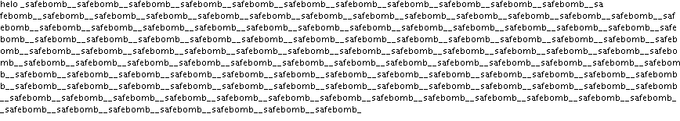

Though there is little reason, why a spammer would use the above technique to send mass emails, the hole in the software poses a security risk. This bug has been fixed in later versions of sendmail.

References
- http://www.faqs.org/rfcs/rfc2821.html
- http://whatis.techtarget.com/definition/0,,sid9_gci782509,00.html
- http://www.codeguru.com/Cpp/I-N/internet/
- http://www.insecure.org/sploits/sendmail.helo.overflow.html
- MSDN Library

