Design Specification

Overview

Major Subsystems and their Relationships
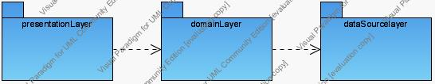

Presentation Layer Design

Domain Layer Design

Data Source Layer Design

